**Course Description**

In this second Python Data Science Toolbox course, you'll continue to build your Python data science skills. First, you'll learn about iterators, objects you have already encountered in the context of for loops.

You'll then learn about list comprehensions, which are extremely handy tools for all data scientists working in Python. You'll end the course by working through a case study in which you'll apply all the techniques you learned in both parts of this course.

**1. Using iterators in PythonLand**

You'll learn all about iterators and iterables, which you have already worked with when writing for loops. You'll learn some handy functions that will allow you to effectively work with iterators. And you’ll finish the chapter with a use case that is pertinent to the world of data science and dealing with large amounts of data—in this case, data from Twitter that you will load in chunks using iterators.



We will learn about iterables, iterators, list comprehensions, and generators - all essential components in the Data Science toolbox.

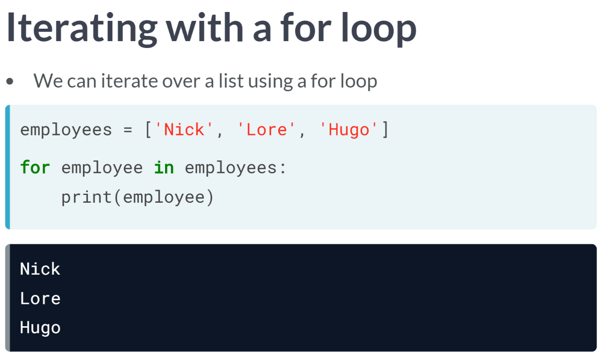  
When you use a for loop to print out each element of a list, you're iterating over the list.

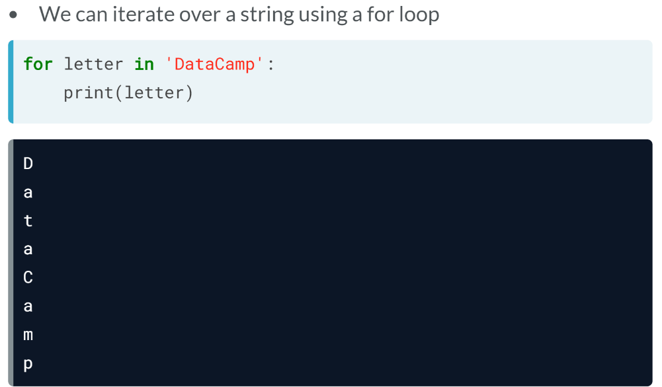  
You can also use a for loop to iterate over characters in a string such as we see here.

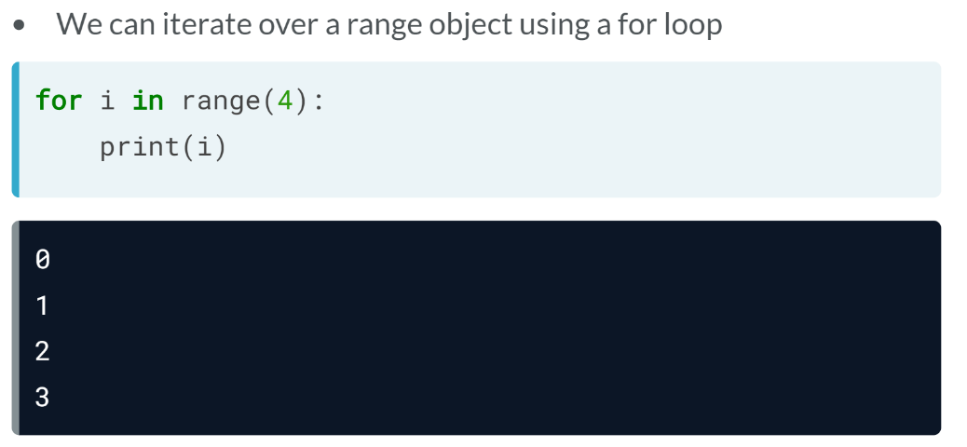  
You can also use a for loop to iterate a sequence of numbers produced by a special range object. The reason we can loop over such object is that they are special objects called iterables: lists, strings, dictionaries, file connections.

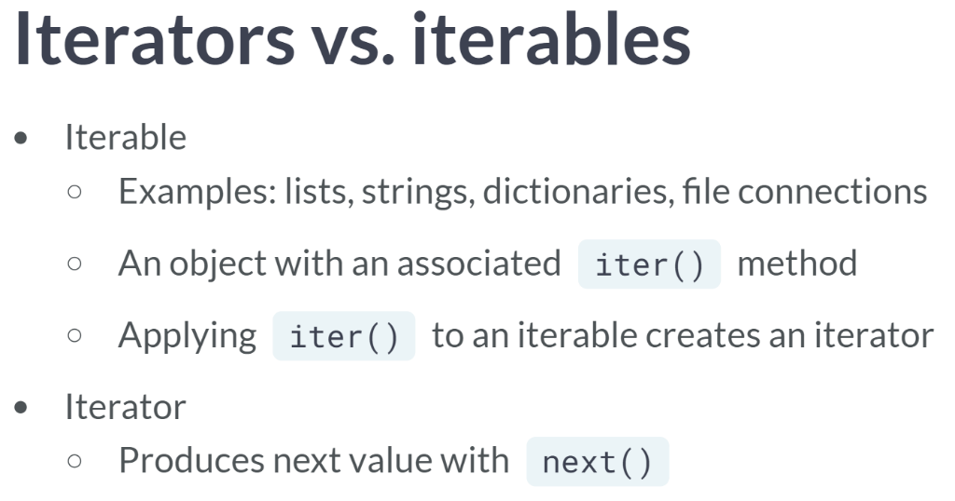  
The actual definition of an iterable is an object that has an associated ***iter()*** method. Once this iter method is applied to an iterable, an iterator object is created. Under the hood, this is actually what the for loop is doing: it takes an iterable, creates the associated iterator object, and iterates over it. An iterator is defined as an object that as an associated next method that produces the consecutive values.

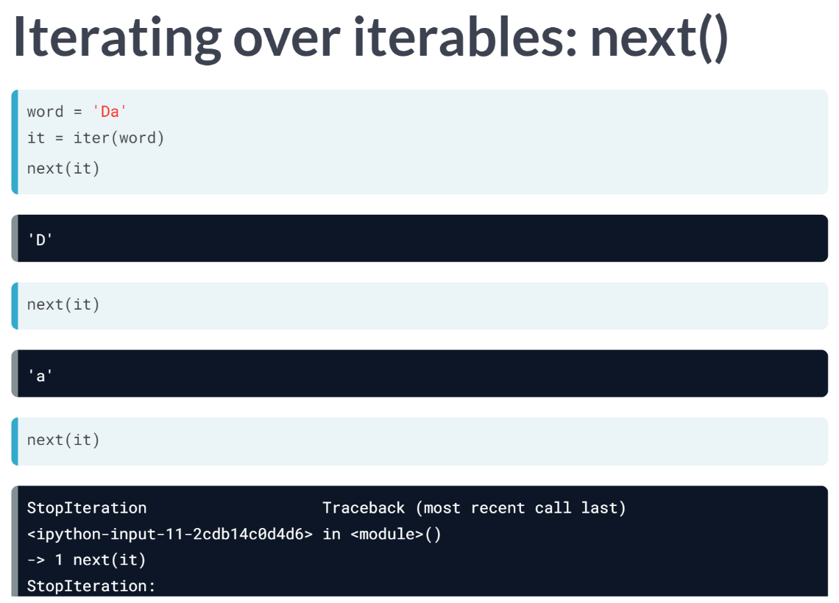  
To create an iterator from iterable, all we need to do is use the function ***iter()*** and pass it the iterable. Once we have the iterator defined, we pass it to the function next, which returns the first value. Calling next again on the iterator returns the next value until there are no values left to return and then it throws us a *StopIteration* error.

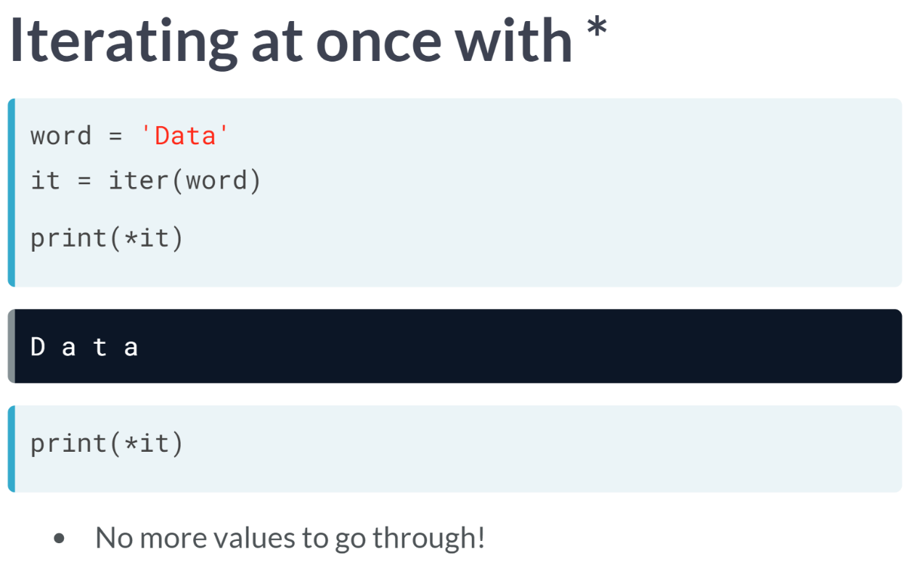  
We can also print all values of an iterator in one fell swoop using the star operator, referred to as the **splat operator** in some circles. This star operator unpacks all elements of an iterator or an iterable.

Keep in mind that once you do so, you cannot do it again as there are no more values through which it can iterate. We would have to redefine our iterator to do so.

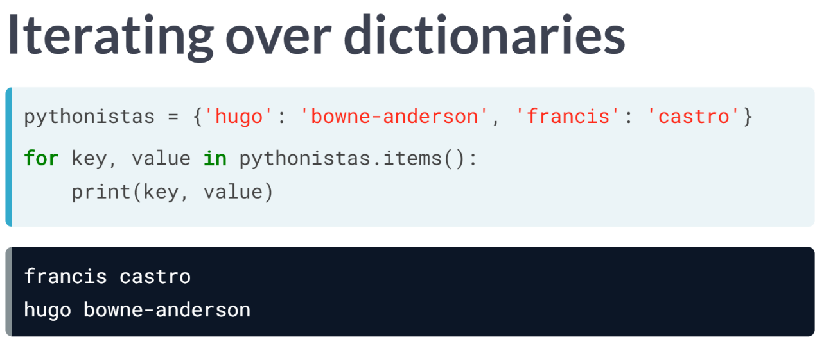  
We mentioned before that dictionaries and file connections are iterables as well. To iterate over the key-value pairs of a Python dictionary, we need to unpack them by applying the ***items()*** method to the dictionary as you can see here.

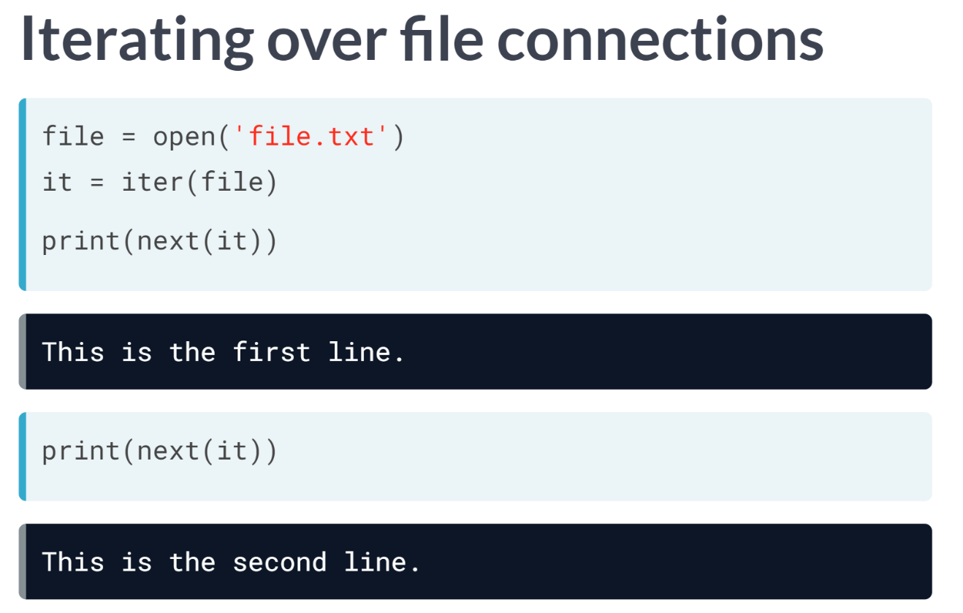  
With respect to file connections, here you can see how to use the iter and next methods to return the lines from a file, *file.txt*. This has been your crash course in the fundamentals of iterables and iterators.

# Iterators vs Iterables

Let's do a quick recall of what you've learned about **iterables** and **iterators**. Recall from the video that an iterable is an object that can return an iterator, while an iterator is an object that keeps state and produces the next value when you call next() on it. In this exercise, you will identify which object is an iterable and which is an iterator.

The environment has been pre-loaded with the variables flash1 and flash2. Try printing out their values with print() and next() to figure out which is an iterable and which is an iterator.

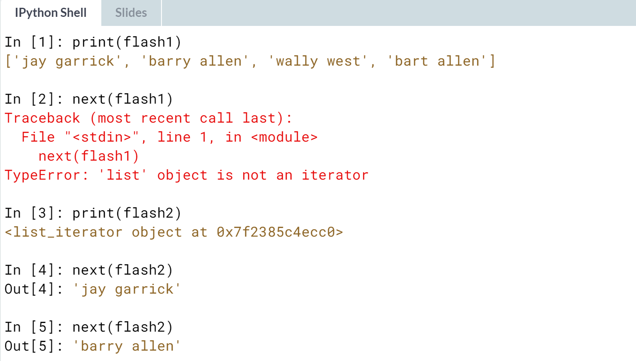

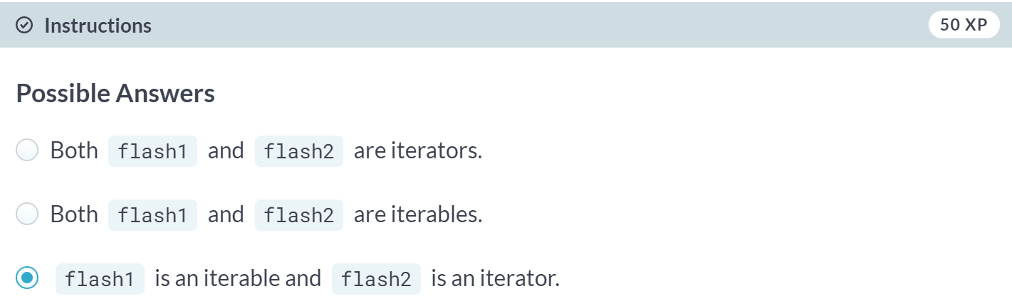

# Iterating over iterables (1)

Great, you're familiar with what iterables and iterators are! In this exercise, you will reinforce your knowledge about these by iterating over and printing from iterables and iterators.

You are provided with a list of strings flash. You will practice iterating over the list by using a for loop. You will also create an iterator for the list and access the values from the iterator.

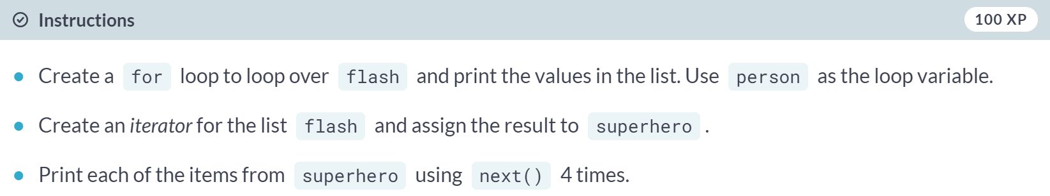  
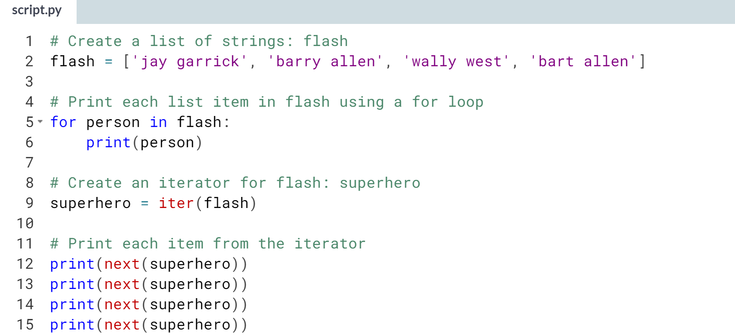  
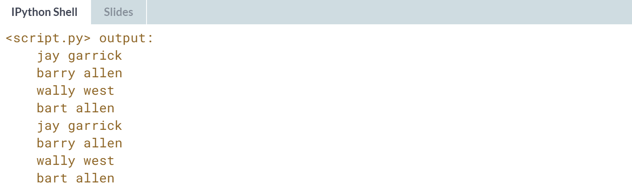

# Iterating over iterables (2)

One of the things you learned about in this chapter is that not all iterables are actual lists. A couple of examples that we looked at are strings and the use of the range() function. In this exercise, we will focus on the range() function.

You can use range() in a for loop as if it's a list to be iterated over:

for i in range(5):

print(i)

Recall that range() doesn't actually create the list; instead, it creates a range object with an iterator that produces the values until it reaches the limit (in the example, until the value 4). If range() created the actual list, calling it with a value of ${10}^{100}$  may not work, especially since a number as big as that may go over a regular computer's memory. The value ${10}^{100}$  is actually what's called a **Googol** which is a 1 followed by a hundred 0s. That's a huge number!

Your task for this exercise is to show that calling range() with ${10}^{100}$  won't actually pre-create the list.

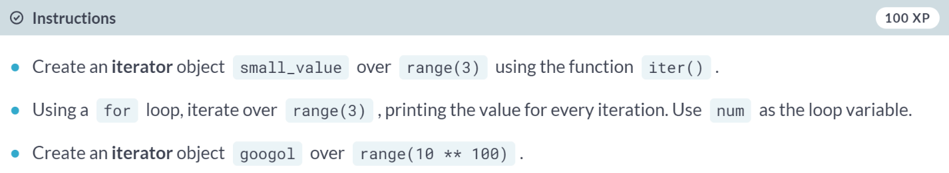  
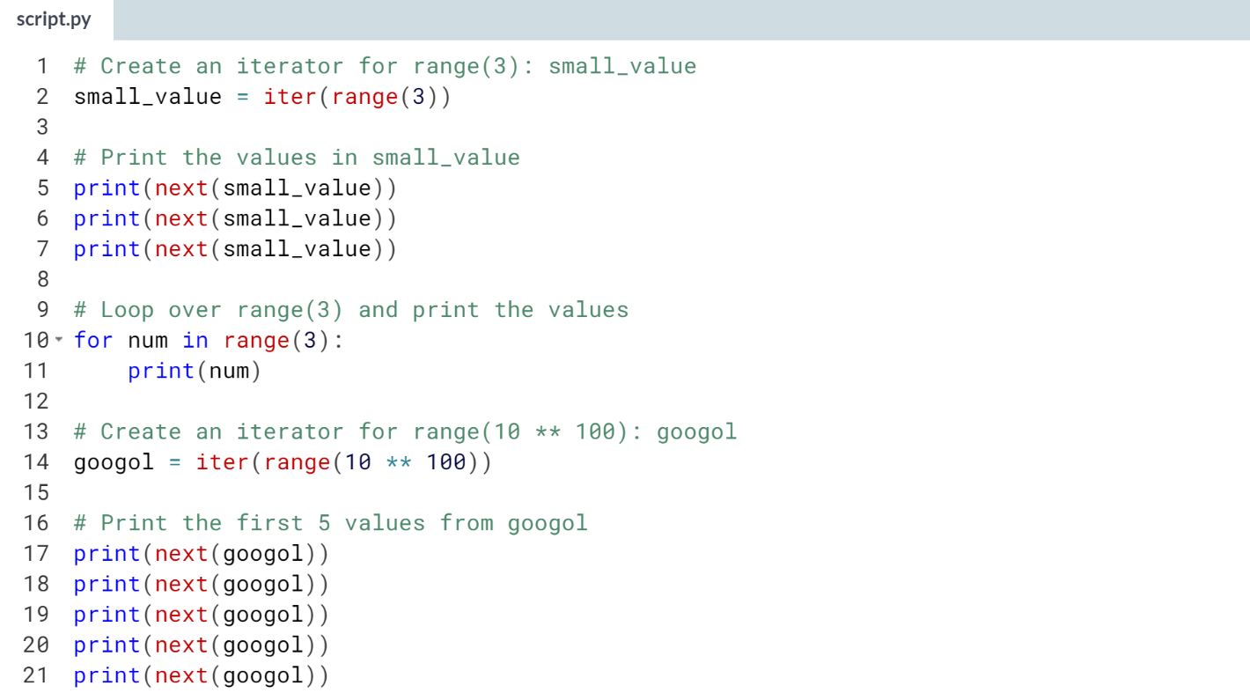  
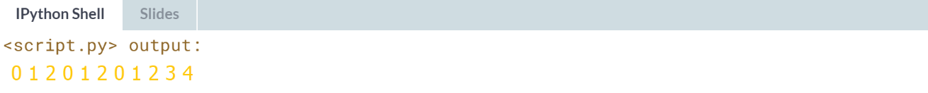

# Iterators as function arguments

You've been using the iter() function to get an iterator object, as well as the next() function to retrieve the values one by one from the iterator object.

There are also functions that take iterators and iterables as arguments. For example, the list() and sum() functions return a list and the sum of elements, respectively.

In this exercise, you will use these functions by passing an iterable from range() and then printing the results of the function calls.

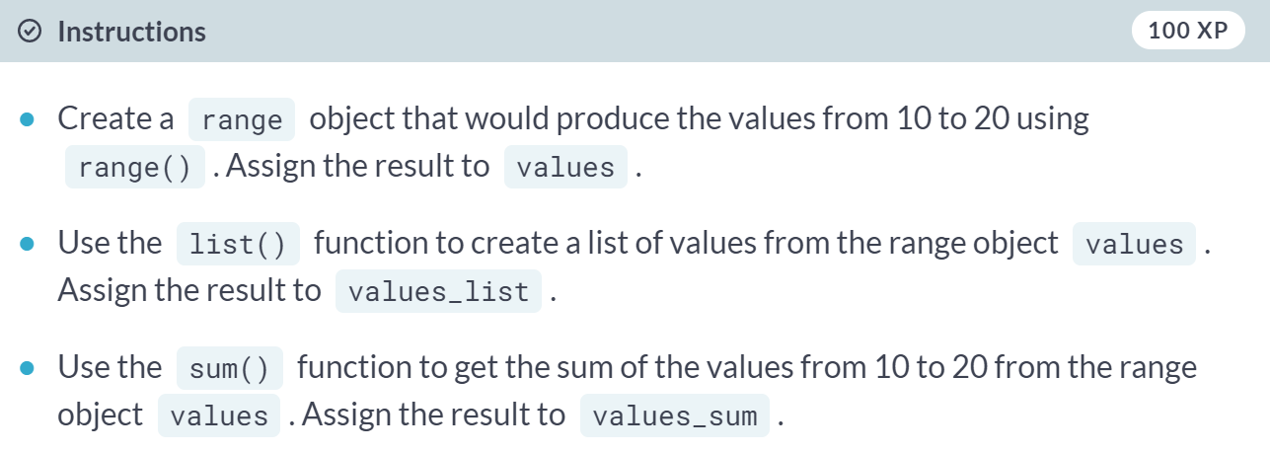  
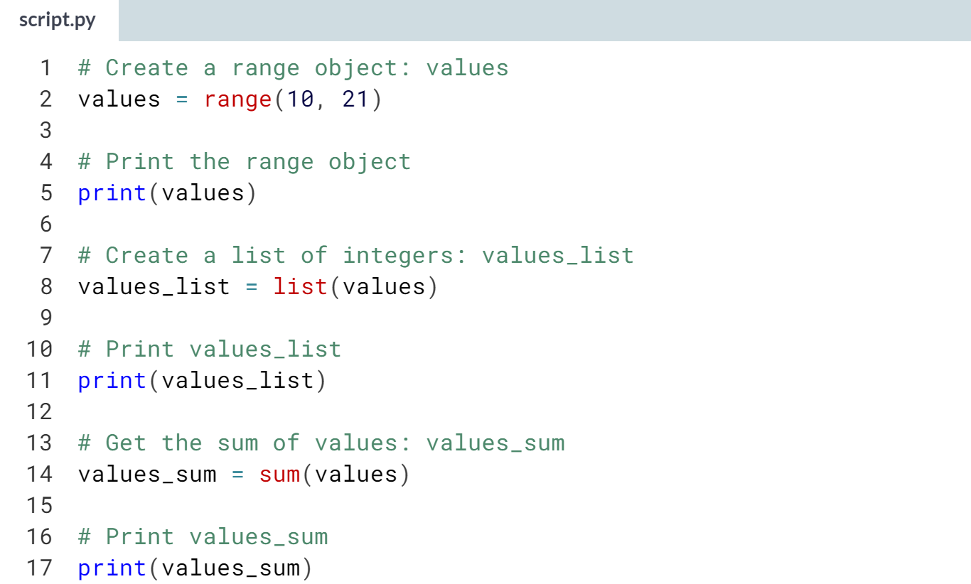  
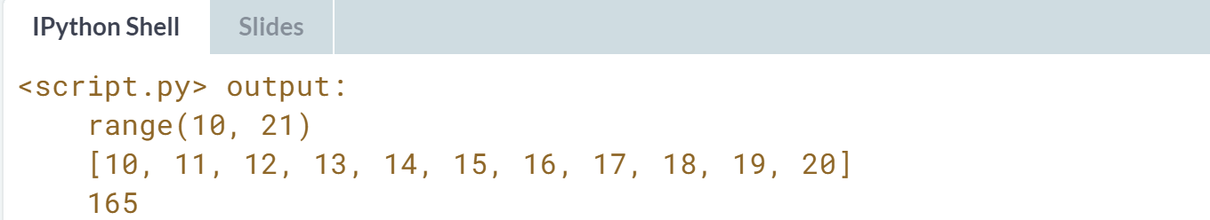



We will learn two functions. The first function, ***enumerate()***, will allow us to add a counter to any iterable while the second function, ***zip()***, will allow us to stitch together an arbitrary number of iterables.

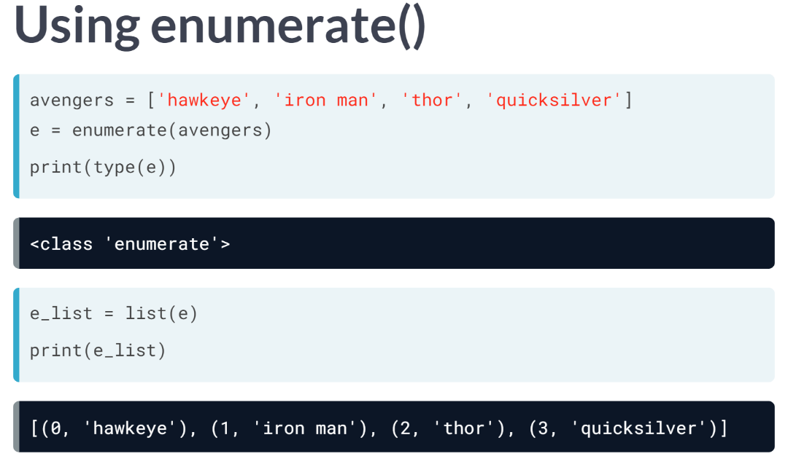  
***enumerate()*** is a function that takes any iterable as argument, such as a list, and returns a special enumerate object, which consists of pairs containing the elements of the original iterable, along with their index within the iterables. Then, we can use the function ***list()*** to turn this enumerate object into a list of tuples and print it to see what it contains.  
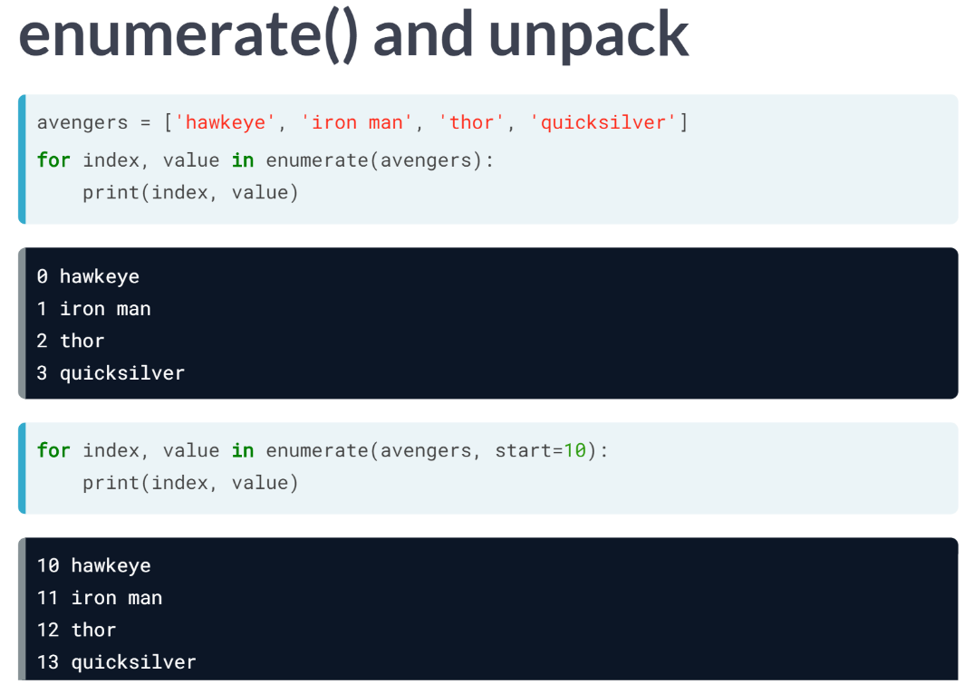  
The enumerate object itself is also an iterable and we can loop over it while unpacking its elements using the clause for *index*, *value*, in enumerate (avengers). It's the default behavior of enumerate to begin indexing at 0. Though, we can alter this with a second argument, *start*.

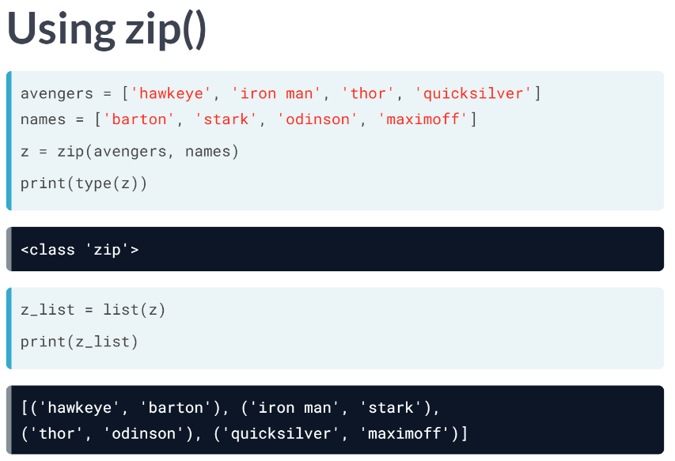  
Let's move on to zip, which accepts an arbitrary number of iterables and returns an iterator of tuples. Here we have two lists, one of the avengers, the other of their names. Zipping them together creates a zip object, which is an iterator of tuples.

We can turn this zip object into a list and print the list. The first element is a tuple containing the first elements of each list that was zipped. The second element is a tuple containing the second elements of each list that was zipped and so on.

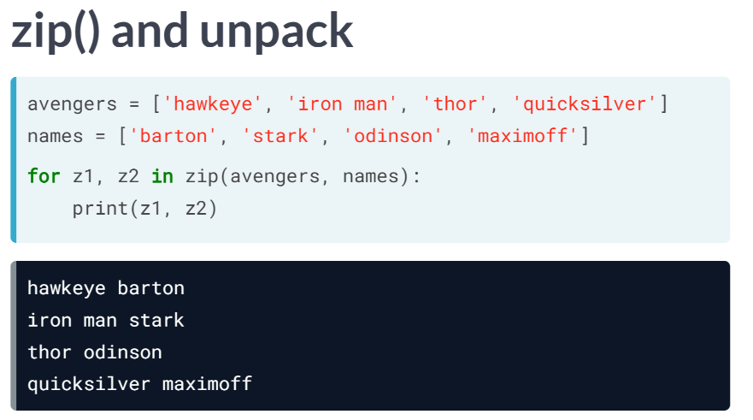  
Alternatively, we could use a for loop to iterate over the zip object and print the tuples.  
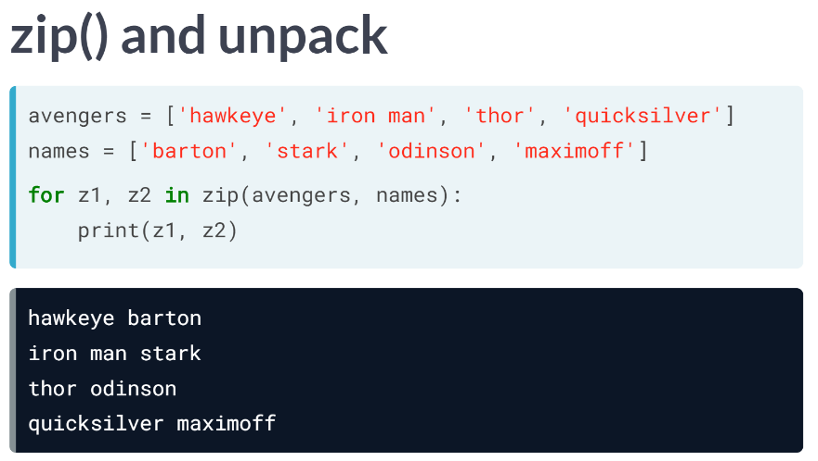  
We could also have used the splat operator to print all the elements.

# Using enumerate

You're really getting the hang of using iterators, great job!

You've just gained several new ideas on iterators from the last video and one of them is the enumerate() function. Recall that enumerate() returns an enumerate object that produces a sequence of tuples, and each of the tuples is an index-value pair.

In this exercise, you are given a list of strings mutants and you will practice using enumerate() on it by printing out a list of tuples and unpacking the tuples using a for loop.

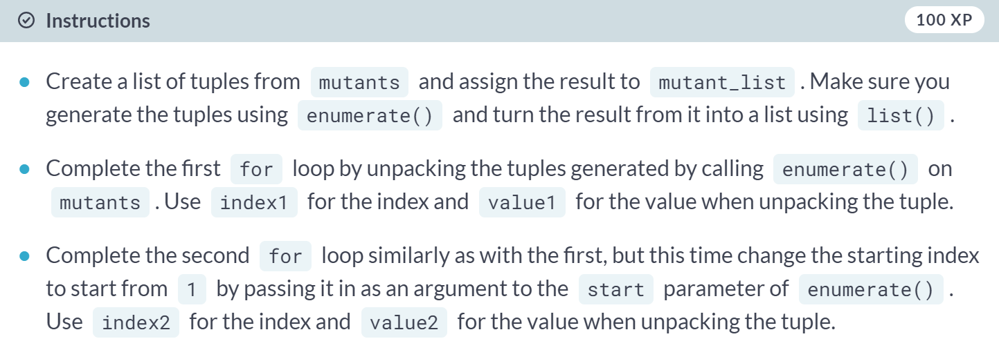  
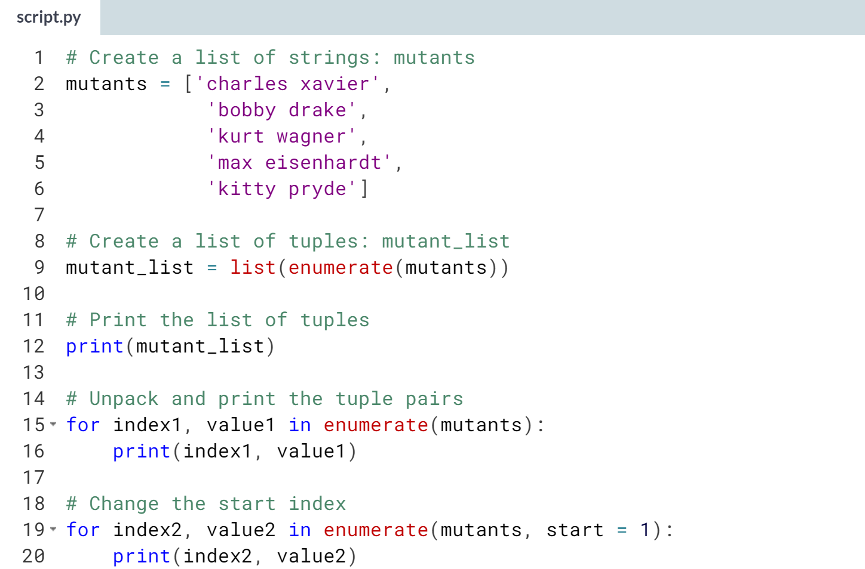

(IPython Shell result on the next page)

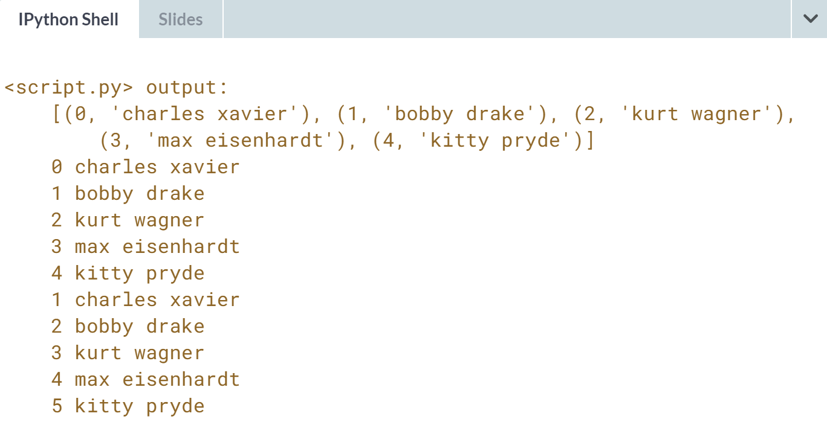

# Using zip

Another interesting function that you've learned is zip(), which takes any number of iterables and returns a zip object that is an iterator of tuples. If you wanted to print the values of a zip object, you can convert it into a list and then print it. Printing just a zip object will not return the values unless you unpack it first. In this exercise, you will explore this for yourself.

Three lists of strings are pre-loaded: mutants, aliases, and powers. First, you will use list() and zip() on these lists to generate a list of tuples. Then, you will create a zip object using zip(). Finally, you will unpack this zip object in a for loop to print the values in each tuple. Observe the different output generated by printing the list of tuples, then the zip object, and finally, the tuple values in the for loop.

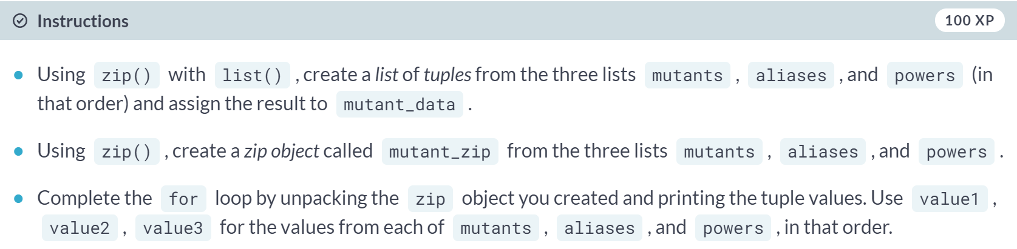

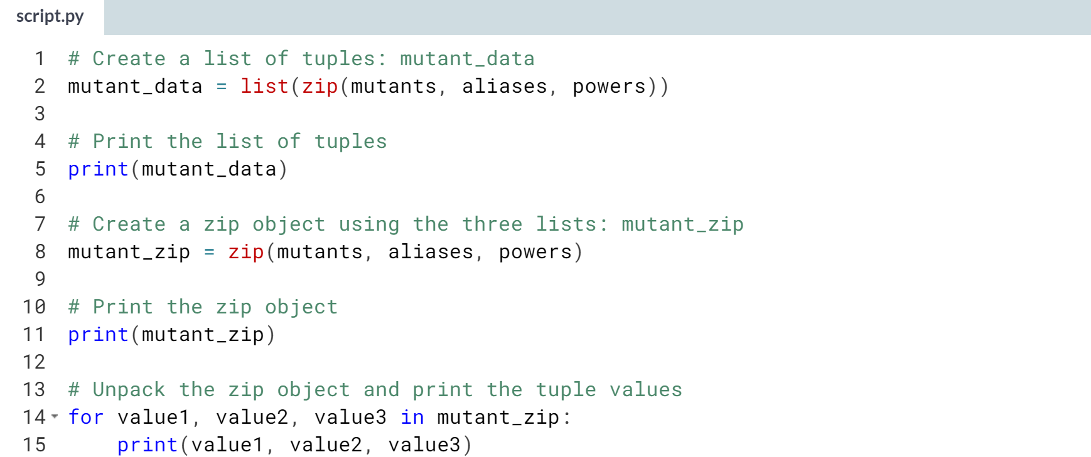  
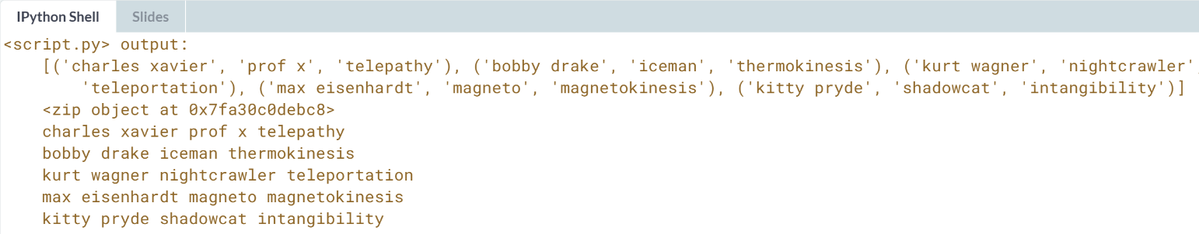

# Using * and zip to 'unzip'

You know how to use zip() as well as how to print out values from a zip object. Excellent!

Let's play around with zip() a little more. There is no unzip function for doing the reverse of what zip() does. We can, however, reverse what has been zipped together by using zip() with a little help from *! * unpacks an iterable such as a list or a tuple into positional arguments in a function call.

In this exercise, you will use * in a call to zip() to unpack the tuples produced by zip().

Two tuples of strings, mutants and powers have been pre-loaded.

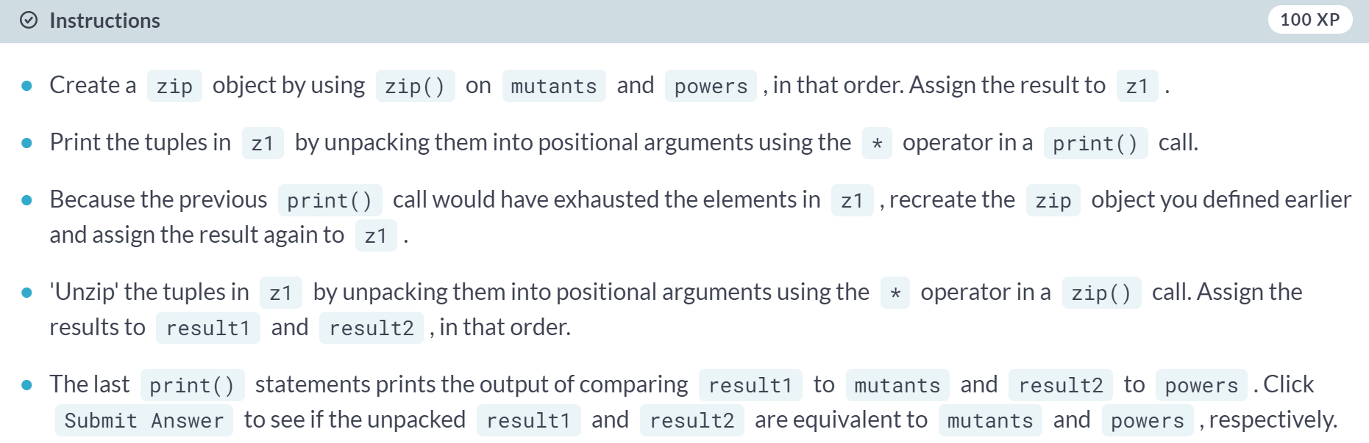  
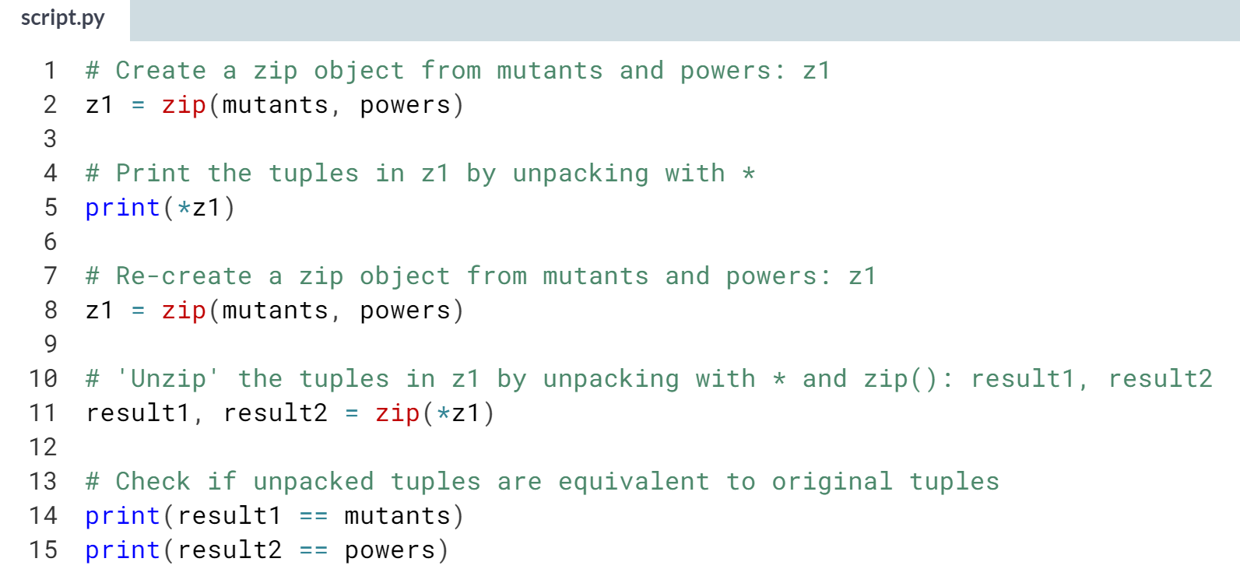  
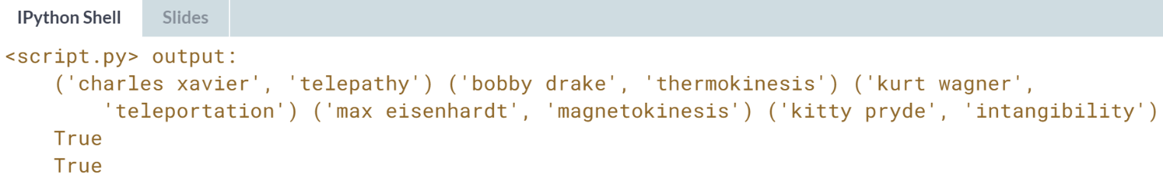

# Processing large amounts of Twitter data

Sometimes, the data we have to process reaches a size that is too much for a computer's memory to handle. This is a common problem faced by data scientists. A solution to this is to process an entire data source chunk by chunk, instead of a single go all at once.

In this exercise, you will do just that. You will process a large csv file of Twitter data in the same way that you processed 'tweets.csv' in [**Bringing it all together**](https://campus.datacamp.com/courses/python-data-science-toolbox-part-1/writing-your-own-functions?ex=12) exercises of the prequel course, but this time, working on it in chunks of 10 entries at a time.

If you are interested in learning how to access Twitter data so you can work with it on your own system, refer to [**Part 2**](https://www.datacamp.com/courses/importing-data-in-python-part-2) of the DataCamp course on Importing Data in Python.

The pandas package has been imported as pd and the file 'tweets.csv' is in your current directory for your use.

Be aware that this is real data from Twitter and as such there is always a risk that it may contain profanity or other offensive content (in this exercise, and any following exercises that also use real Twitter data).

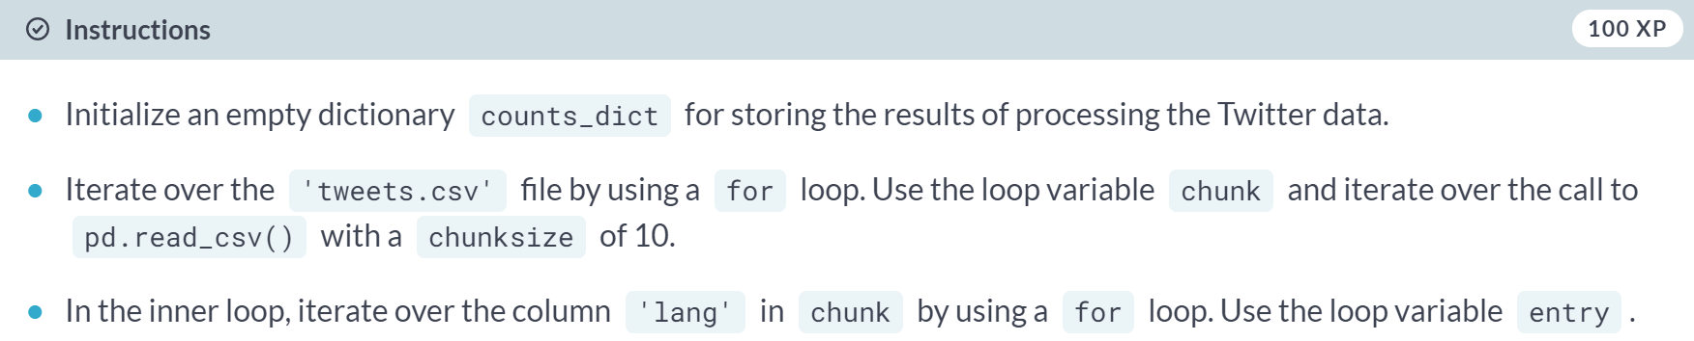  
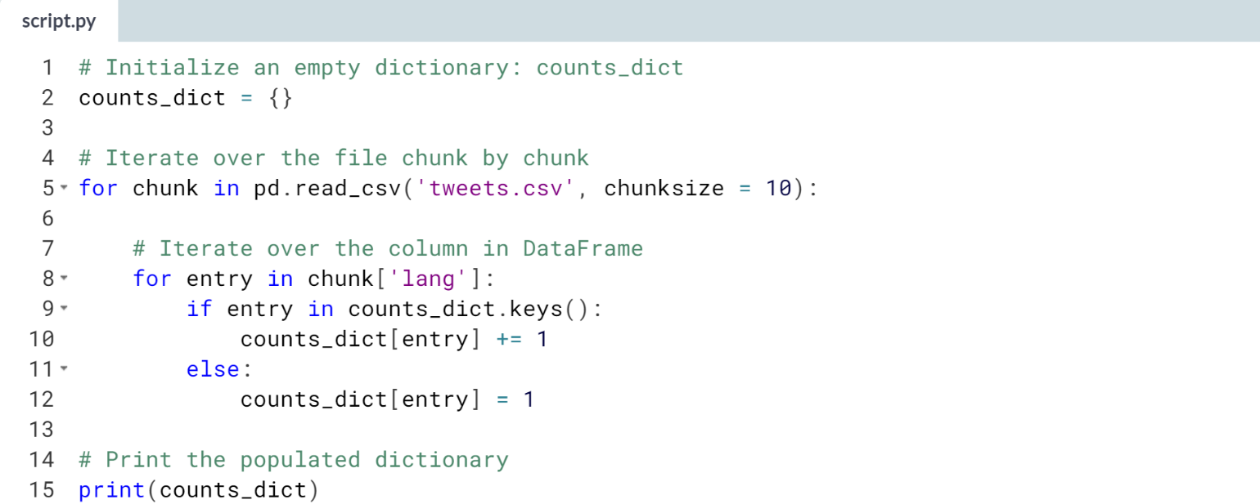  


# Extracting information for large amounts of Twitter data – **REVIEW**

Great job chunking out that file in the previous exercise. You now know how to deal with situations where you need to process a very large file and that's a very useful skill to have!

It's good to know how to process a file in smaller, more manageable chunks, but it can become very tedious having to write and rewrite the same code for the same task each time. In this exercise, you will be making your code more reusable by putting your work in the last exercise in a function definition.

The pandas package has been imported as pd and the file 'tweets.csv' is in your current directory for your use.

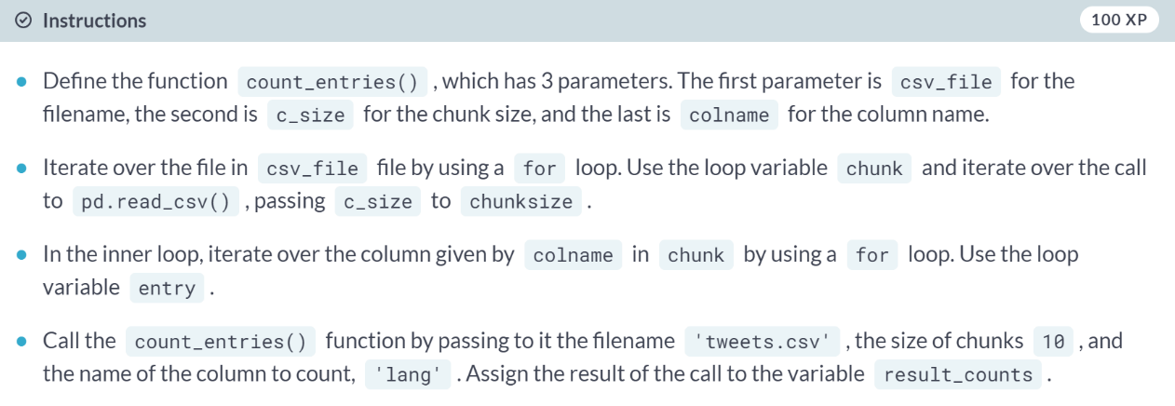  
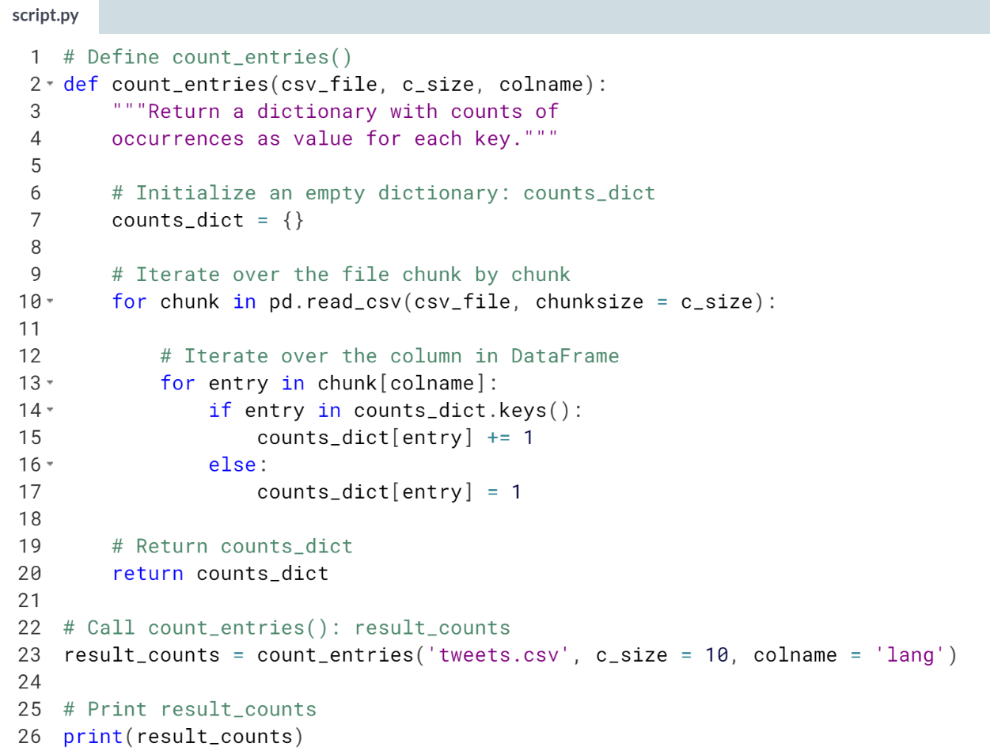  




We are going to check out a particular use case that is pertinent to the world of Data Science: dealing with large amounts of data.

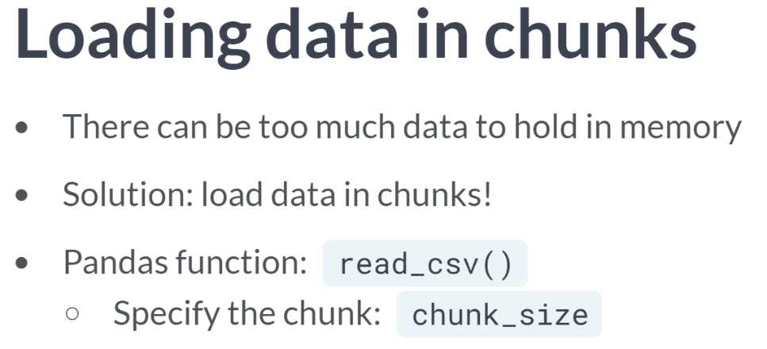  
Let's say that you are pulling data from a file, database, or API and there's so much of it, just so much data, that you can't hold it in memory.

One solution is to load the data in chunks, perform the desired operation or operations on each chunk, store the result, discard the chunk and then load the next chunk; this sounds like a place where an iterator could be really useful.

To surmount this challenge, we are going to use the pandas function ***read_csv()***, which provides a wonderful option whereby you can load data in chunks and iterate over them. All we need to do is to specify the chunk using the argument, *chunk_size*.

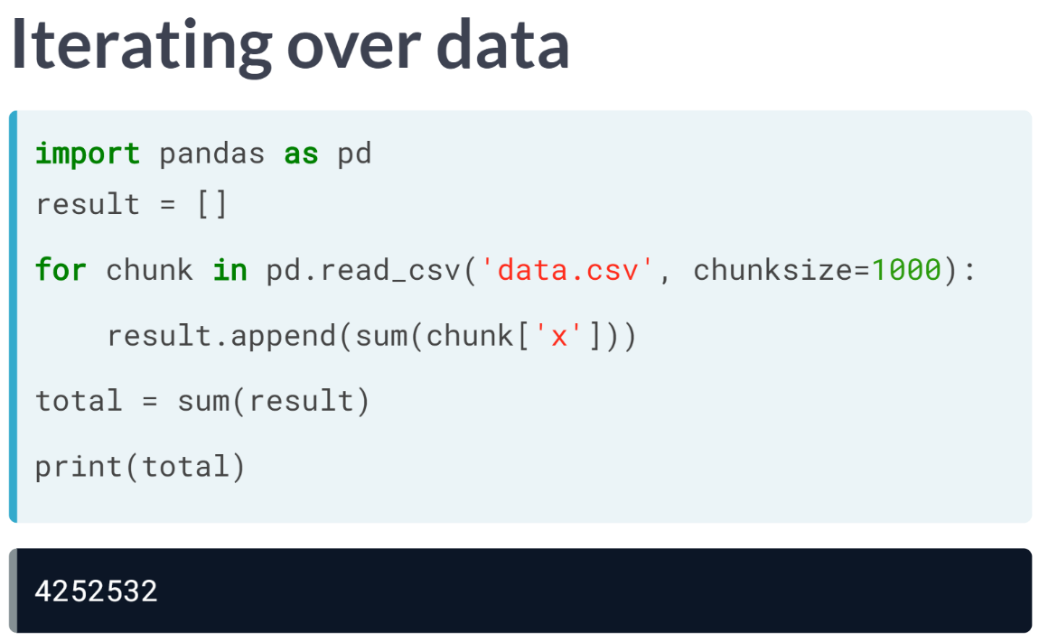  
Let's say that we have a csv with a column called 'x' of numbers and I want to compute the sum of all the numbers in that column. However, the file is too large to store in memory.

We first import pandas and then initialize an empty list result to hold the result of each iteration. We then use the ***read_csv()*** function, utilizing the argument chunk_size, setting it to the size of the chunks we want to read in.

The object created by the ***read_csv()*** call is an iterable so we can iterate over it, using a for loop, in which each chunk will be a DataFrame. Within the for loop, that is, on each iteration, we compute the sum of the column of interest and we append it to the list result.

Once this is executed, we can take the sum of the list result, and this gives us our total sum of the column of interest.  
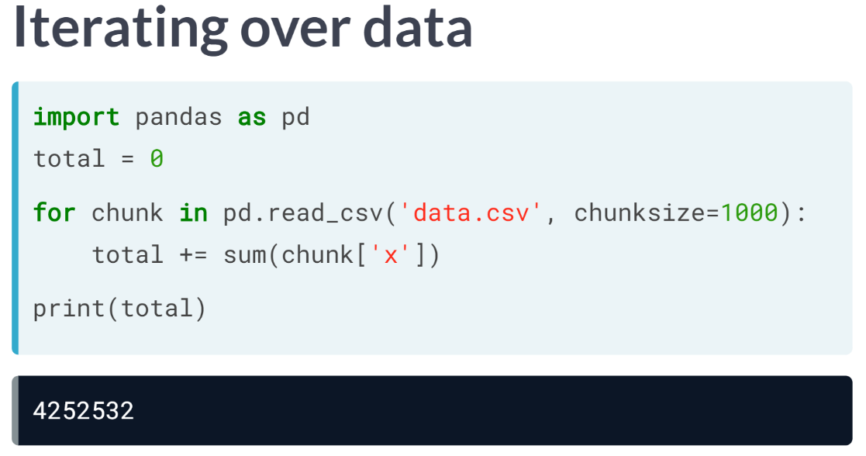  
Also note that we need not have used a list to store each result - we could have initialized total to zero before iterating over the file and added each sum during the iteration procedure, as you can see here.

This is where the things get so cool - we are going to use iterator to load Twitter data in chunks and perform a similar computation that you did in the prequel to this course. Then we are going to write a function that does the same.



Now you've grappled with the nuts and bolts of iterators in Python Land and survived.

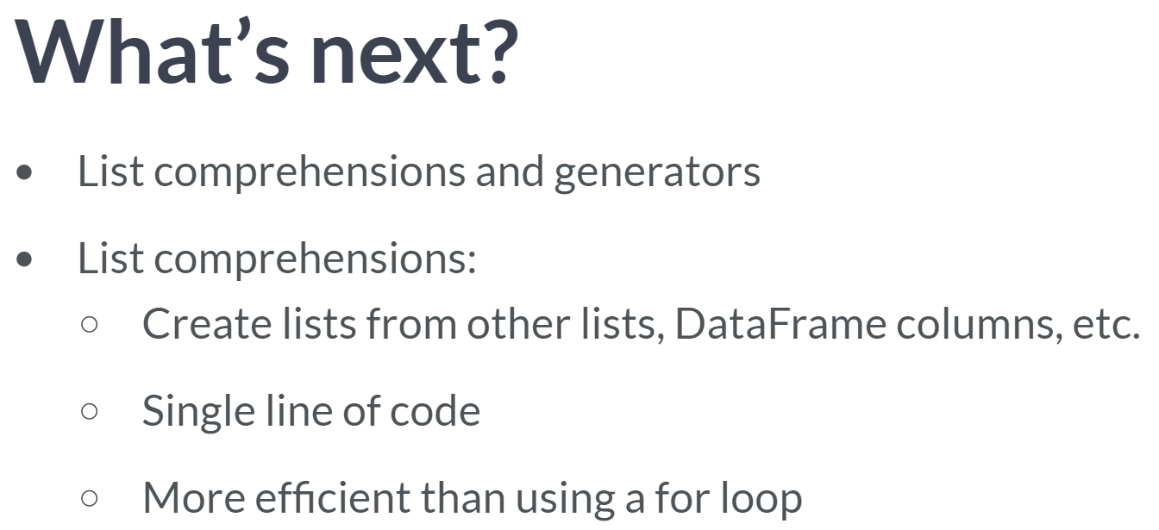  
This is one of a number of data science tools that we will learn in the course. Moreover, the entire final chapter of this course is dedicated to using skills we are developing to extract meaningful information from a real world data set, the World Bank Development Indicators dataset, which presents the most current and accurate global development data available, and includes national, regional, and global estimates.

**2. List comprehensions and generators**

In this chapter, you'll build on your knowledge of iterators and be introduced to list comprehensions, which allow you to create complicated lists—and lists of lists—in one line of code!

List comprehensions can dramatically simplify your code and make it more efficient and will become a vital part of your Python data science toolbox.

You'll then learn about generators, which are extremely helpful when working with large sequences of data that you may not want to store in memory, but instead generate on the fly.



Let's say that you have a list of number sand you want to create a new list of numbers that's the same as the old list, except that each number has 1 added to it.

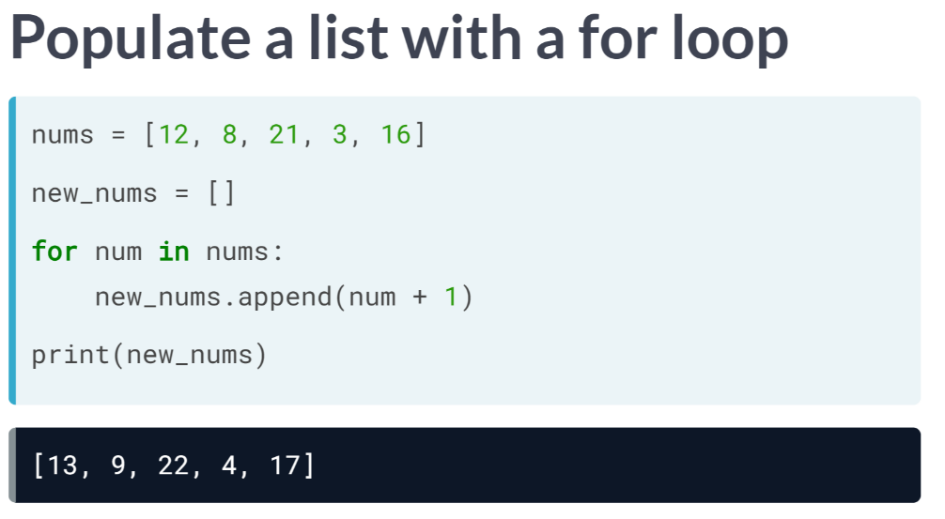  
You could initialize a new empty list, loop through the old list, add 1 to each entry and append all new values to the new list, but for loops are inefficient, both computationally and in terms of coding time and space, particularly when you could do this in one line of code.

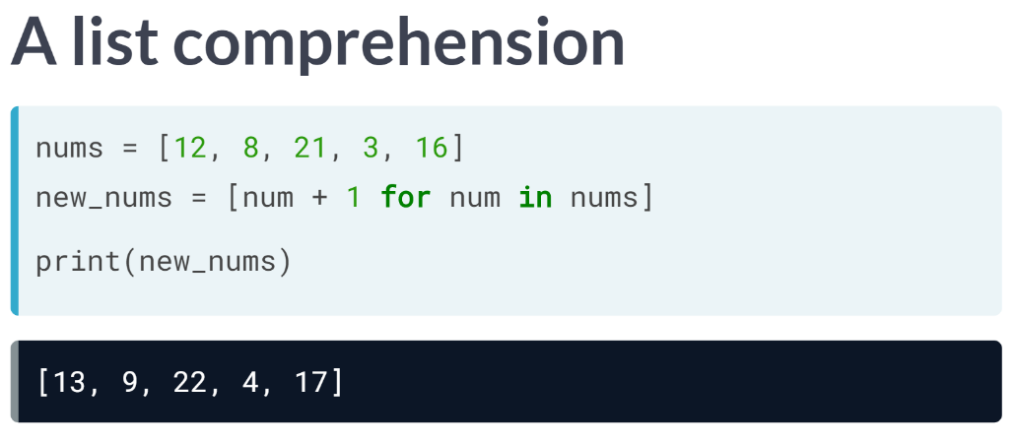  
The syntax is as follows: within square brackets, you write the values you wish to create, otherwise known as the output expression, followed by the for clause referencing the original list.

So, in our case, you open the square bracket, followed by **num + 1 for num in nums** and then you close the square bracket. This is a list comprehension and precisely creates the desired list.

See here the relationship between the for-loop syntax and the list comprehension syntax. The power of list comprehensions is not merely relegated to the world of lists; however, you can write a list comprehension over any iterable.

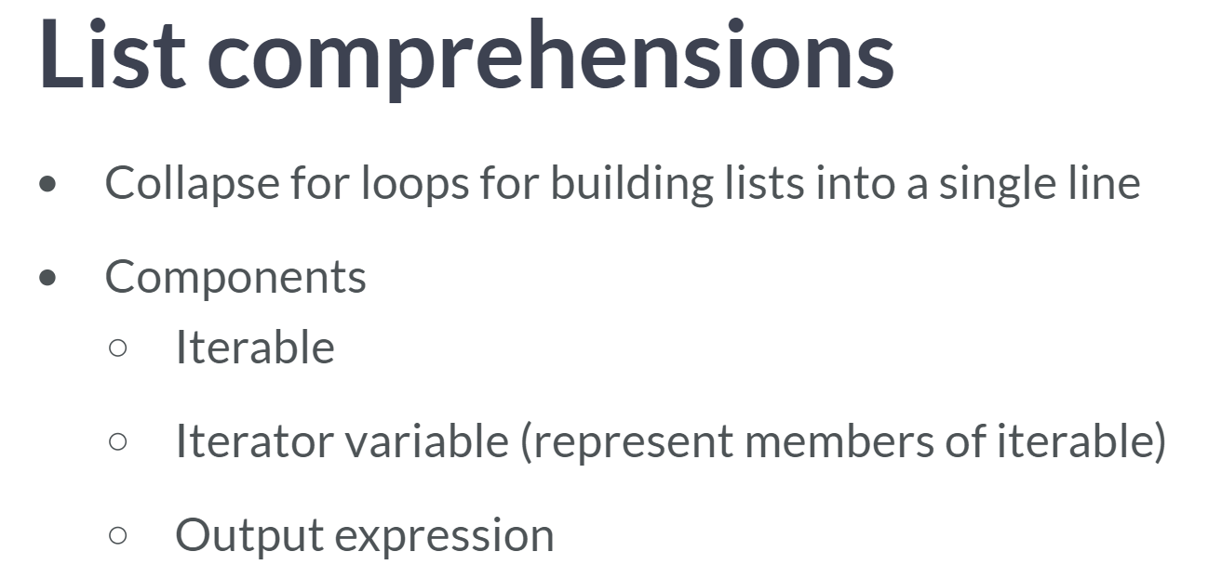  
Here's an example of a list comprehension using a range object.

To summarize, list comprehension collapse for loop for building lists into a single line and the required components are   
1) an iterable,   
2) an iterator variable that represents the members of the iterable, and   
3) an output expression. We can also use list comprehensions in place of nested for loops.

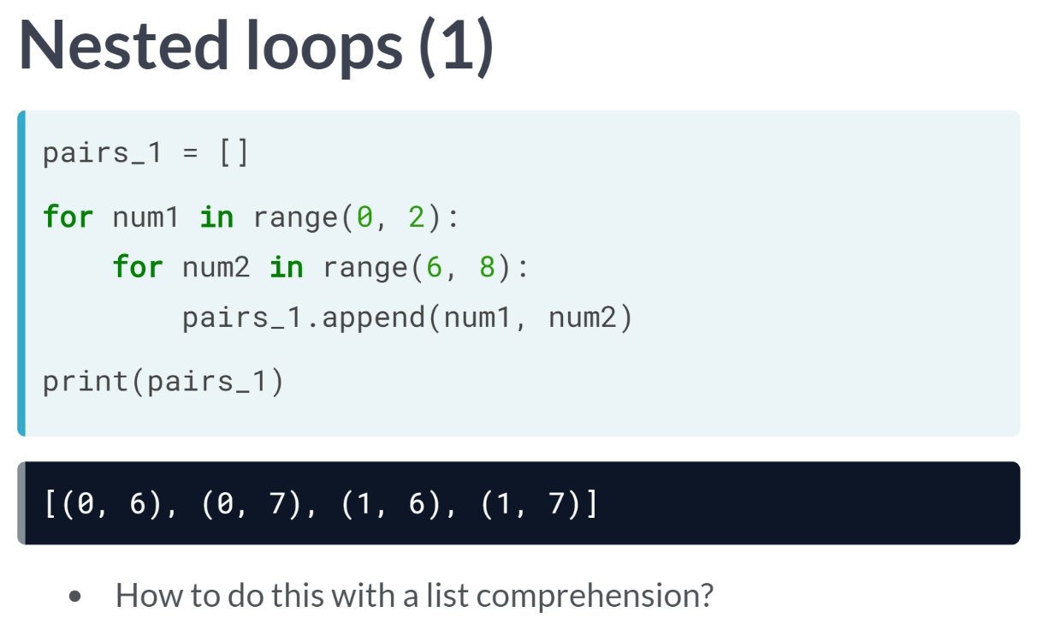  
For example, let's say that we wanted to create a list of all pairs of integers where the first integer is between 0 and 1 and the second between 6 and 7.

This nested for loop would produce the required result. The question is, can we do the same with a list comprehension? And the answer is, yes, as follows.

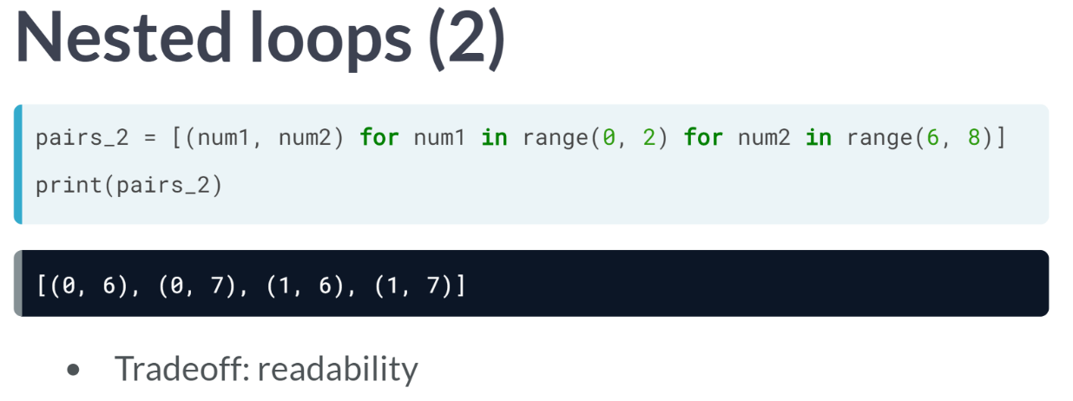  
Once again, within the square brackets, place the desired output expression followed by the two required for loop clauses.

You may have observed that while it keeps to a single line of code, we sacrifice some readability of the code as a tradeoff, so you will have to consider if you'd like to use list comprehensions in cases such as this.

# Write a basic list comprehension

In this exercise, you will practice what you've learned from the video about writing list comprehensions. You will write a list comprehension and identify the output that will be produced.

The following list has been pre-loaded in the environment.

doctor = ['house', 'cuddy', 'chase', 'thirteen', 'wilson']

How would a list comprehension that produces a list of the **first character** of each string in doctor look like? Note that the list comprehension uses doc as the iterator variable. What will the output be?

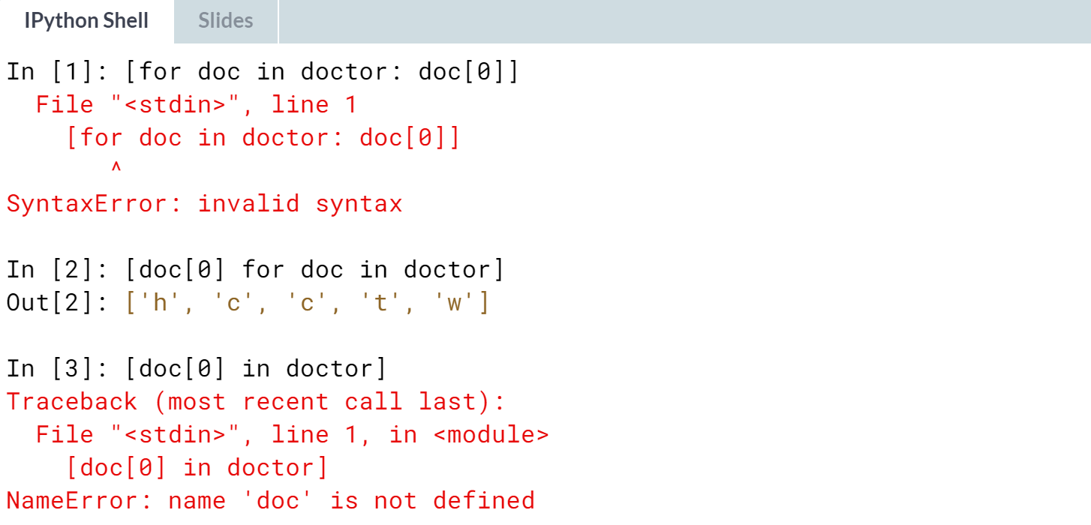

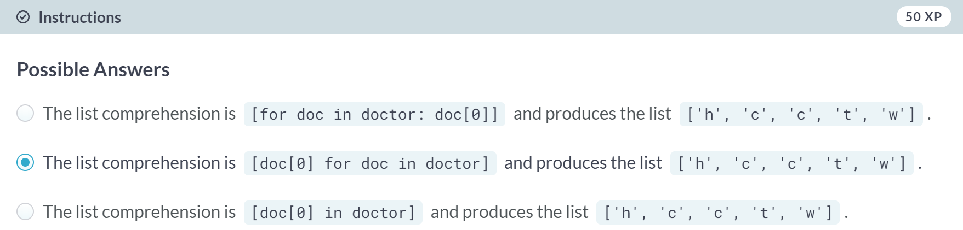

# List comprehension over iterables

You know that list comprehensions can be built over iterables. Given the following objects below, which of these can we build list comprehensions over?

doctor = ['house', 'cuddy', 'chase', 'thirteen', 'wilson']

range(50)

underwood = 'After all, we are nothing more or less than what we choose to reveal.'

jean = '24601'

flash = ['jay garrick', 'barry allen', 'wally west', 'bart allen']

valjean = 24601

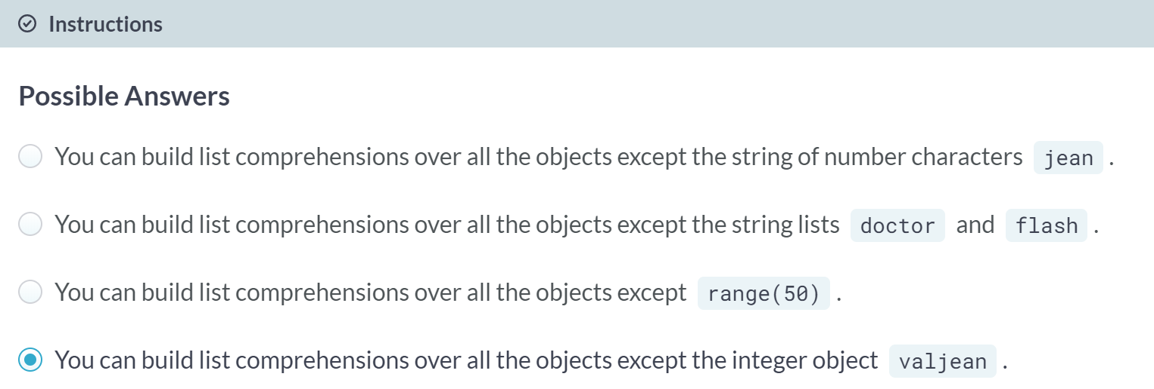

# Writing list comprehensions

You now have all the knowledge necessary to begin writing list comprehensions! Your job in this exercise is to write a list comprehension that produces a list of the squares of the numbers ranging from 0 to 9.

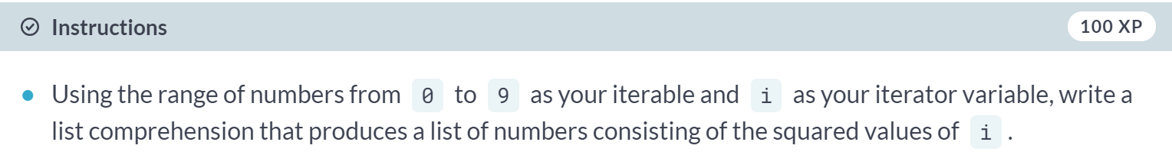

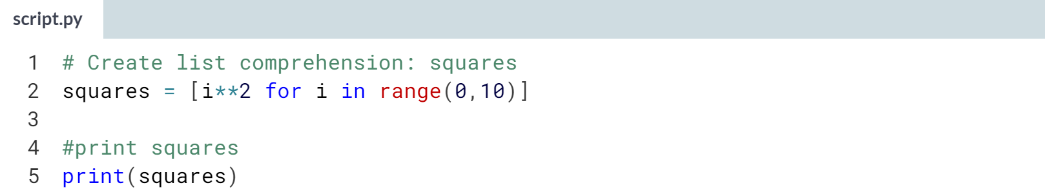

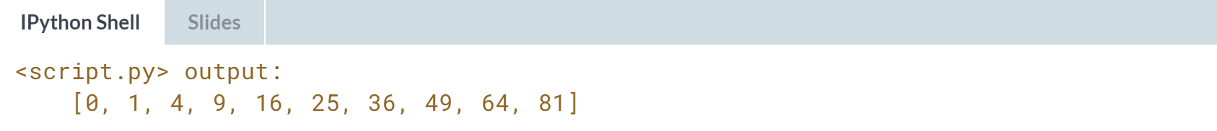

# Nested list comprehensions

Great! At this point, you have a good grasp of the basic syntax of list comprehensions. Let's push your code-writing skills a little further. In this exercise, you will be writing a list comprehension within another list comprehension, or nested list comprehensions. It sounds a little tricky, but you can do it!

Let's step aside for a while from strings. One of the ways in which lists can be used are in representing multi-dimension objects such as **matrices**. Matrices can be represented as a list of lists in Python. For example, a 5 x 5 matrix with values 0 to 4 in each row can be written as:

matrix = [[0, 1, 2, 3, 4],

[0, 1, 2, 3, 4],

[0, 1, 2, 3, 4],

[0, 1, 2, 3, 4],

[0, 1, 2, 3, 4]]

Your task is to recreate this matrix by using nested listed comprehensions. Recall that you can create one of the rows of the matrix with a single list comprehension. To create the list of lists, you simply have to supply the list comprehension as the **output expression** of the overall list comprehension:

[[output expression] for iterator variable in iterable]

Note that here, the **output expression** is itself a list comprehension.

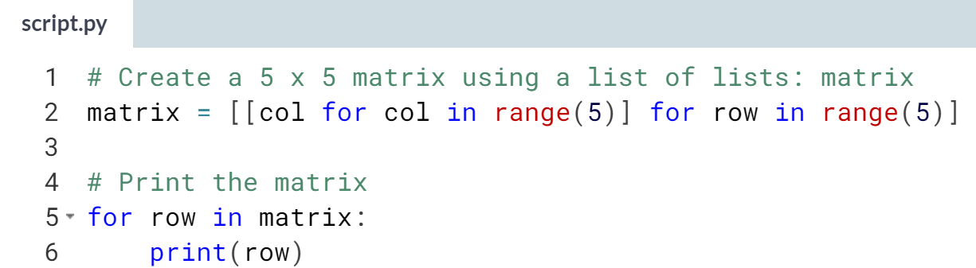

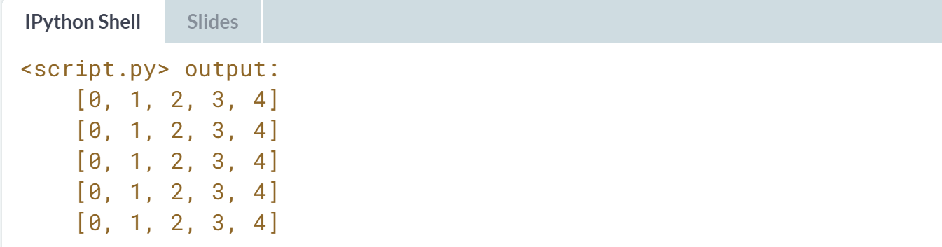



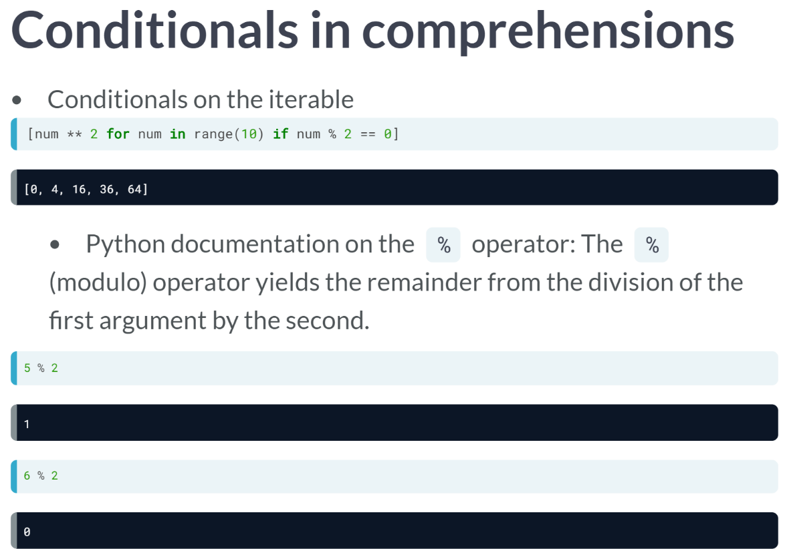

Let's check out more advanced comprehension capabilities, such as conditionals.

Here we see that we can filter the output of a list comprehension using a conditional on the iterable: in this example, the resulting list is the square of the values in range(10) under the condition that the value itself is even.

To recall, modulo operator produces the remainder from the division of the first argument by the second.

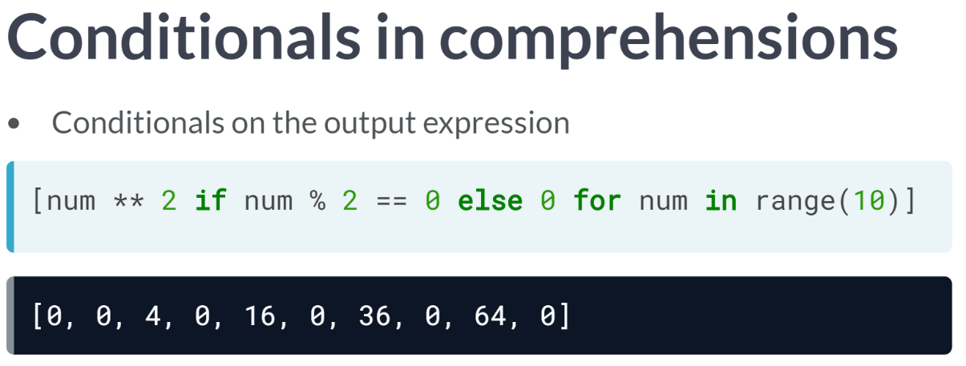  
We can also condition the list comprehension on the output expression. Here, for an even integer we output its square. In any other case, signified by the else clause, that is for odd integers, we output 0.

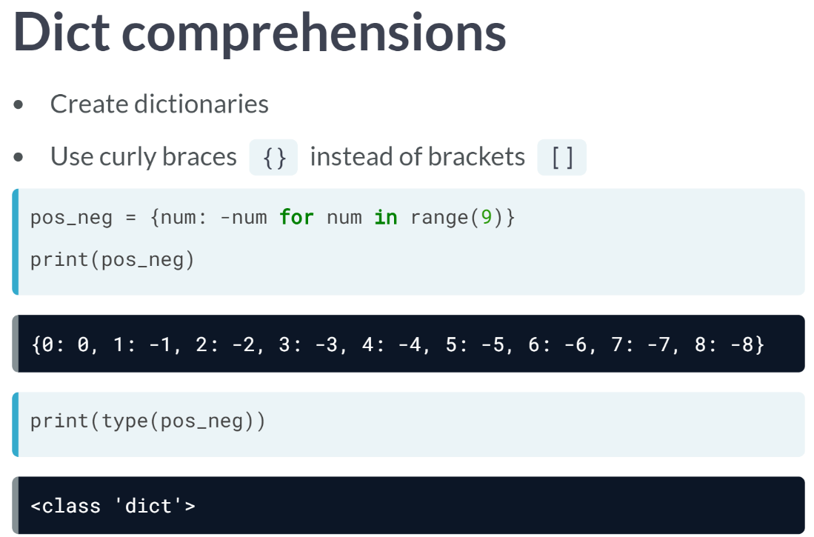  
We can also write dictionary comprehension to create new dictionaries from iterables. The syntax is almost the same as in list comprehensions and there are two differences.

One, we use curly braces instead of square brackets.

Two, the key and value are separated by a colon in the output expressions as we can see here.

In this example, we are creating a dictionary with keys positive integers and corresponding values the respective negative integers.

# Using conditionals in comprehensions (1) – **REVIEW**

You've been using list comprehensions to build lists of values, sometimes using operations to create these values.

An interesting mechanism in list comprehensions is that you can also create lists with values that meet only a certain condition. One way of doing this is by using conditionals on iterator variables. In this exercise, you will do exactly that!

Recall from the video that you can apply a conditional statement to test the iterator variable by adding an if statement in the optional predicate expression part after the for statement in the comprehension:

[ output expression for iterator variable in iterable if predicate expression ].

You will use this recipe to write a list comprehension for this exercise. You are given a list of strings fellowship and, using a list comprehension, you will create a list that only includes the members of fellowship that have 7 characters or more.

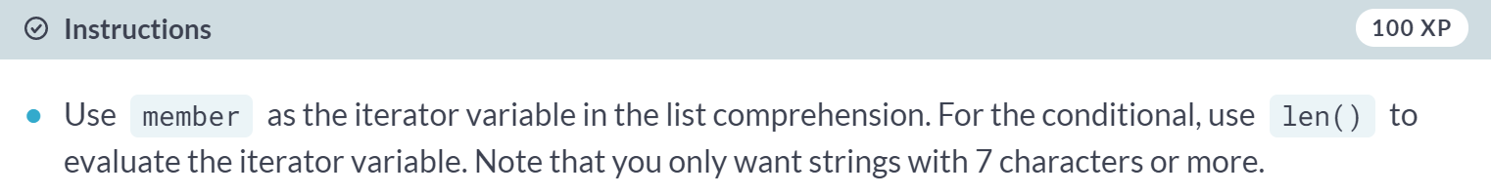

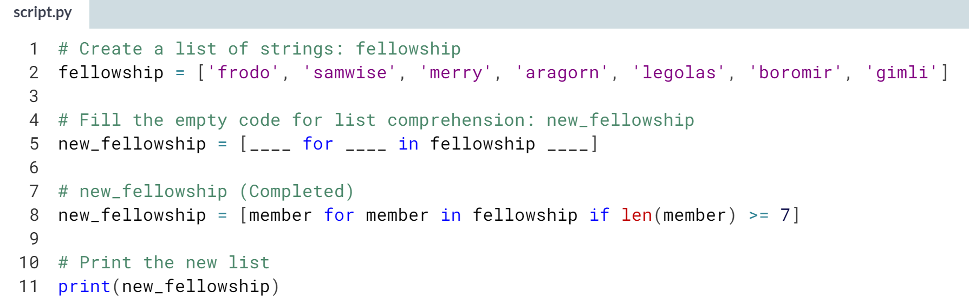



# Using conditionals in comprehensions (2)

In the previous exercise, you used an if conditional statement in the predicate expression part of a list comprehension to evaluate an iterator variable. In this exercise, you will use an if-else statement on the output expression of the list.

You will work on the same list, fellowship and, using a list comprehension and an if-else conditional statement in the output expression, create a list that keeps members of fellowship with 7 or more characters and replaces others with an empty string. Use member as the iterator variable in the list comprehension.

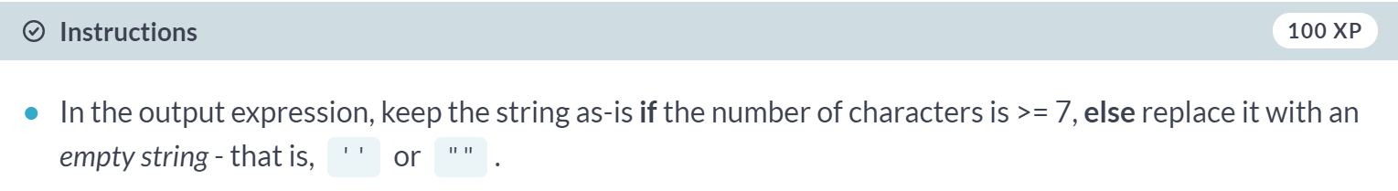  
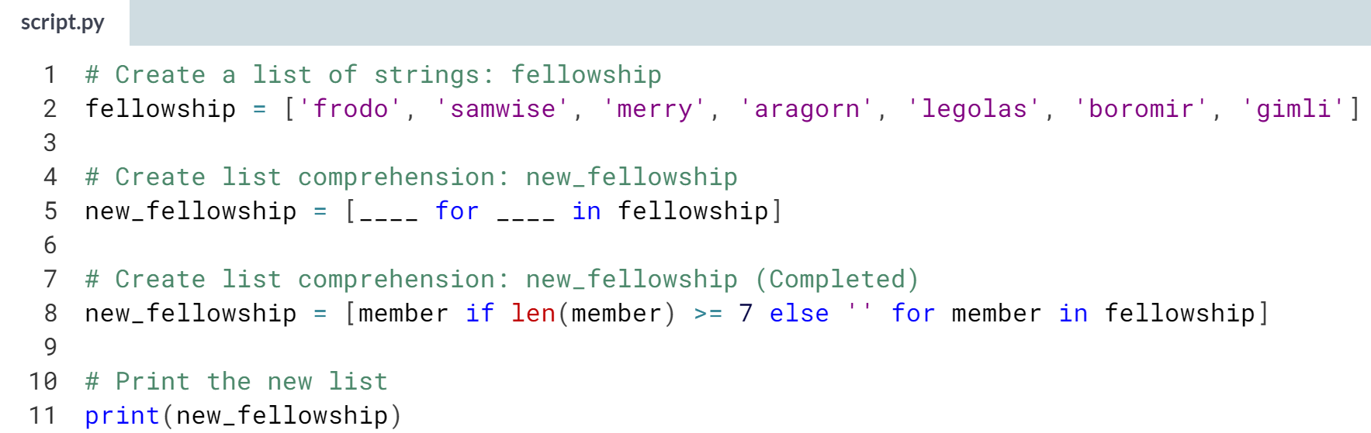



# Dict comprehensions

Comprehensions aren't relegated merely to the world of lists. There are many other objects you can build using comprehensions, such as dictionaries, pervasive objects in Data Science. You will create a dictionary using the comprehension syntax for this exercise. In this case, the comprehension is called a **dict comprehension**.

Recall that the main difference between a list comprehension and a dict comprehension is the use of curly braces {} instead of []. Additionally, members of the dictionary are created using a colon :, as in <key> : <value>.

You are given a list of strings fellowship and, using a **dict comprehension**, create a dictionary with the members of the list as the keys and the length of each string as the corresponding values.

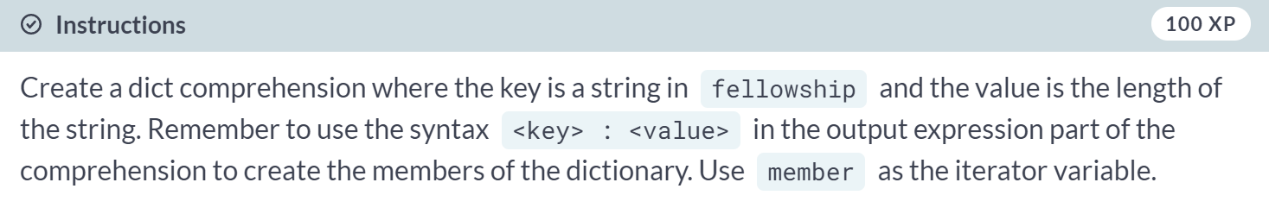

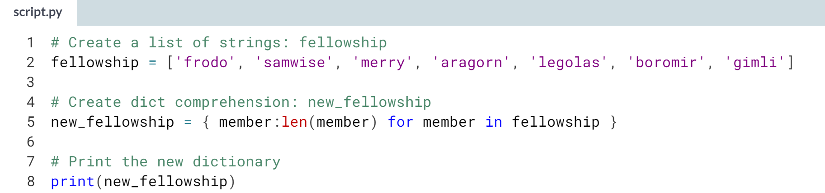

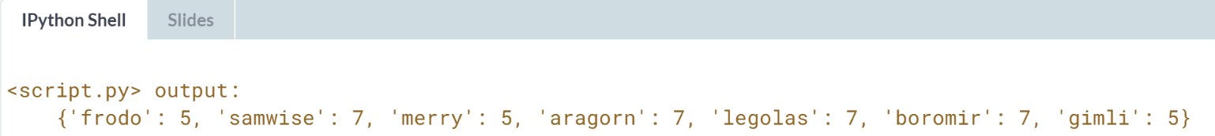



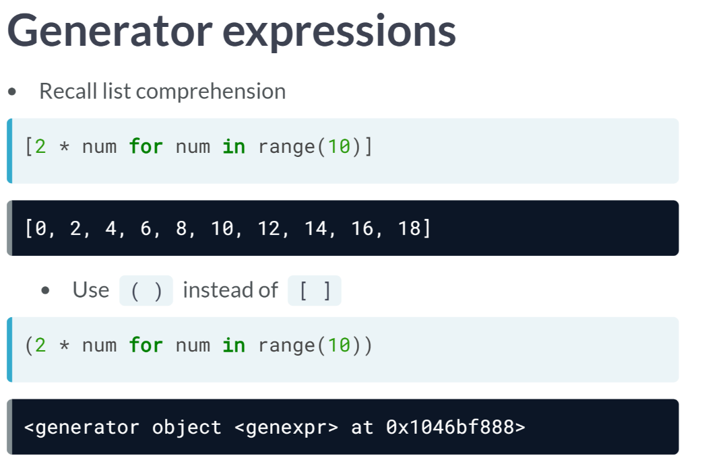  
Recall that this list comprehension will create a list of the first 10 even numbers. Now let's replace the square brackets with round parentheses and voila!

Something called a generator object has been created. Now the question on everybody's lips is, "What is this generator object?"

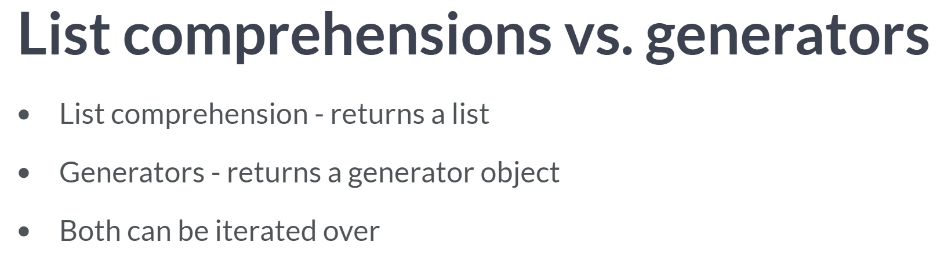  
Now the question on everybody's lip is, "What is this generator object?". Well, a generator is like a list comprehension except it doesn't store the list in memory: it does not construct the list but is an object we can iterate over to produce elements of the list as required.

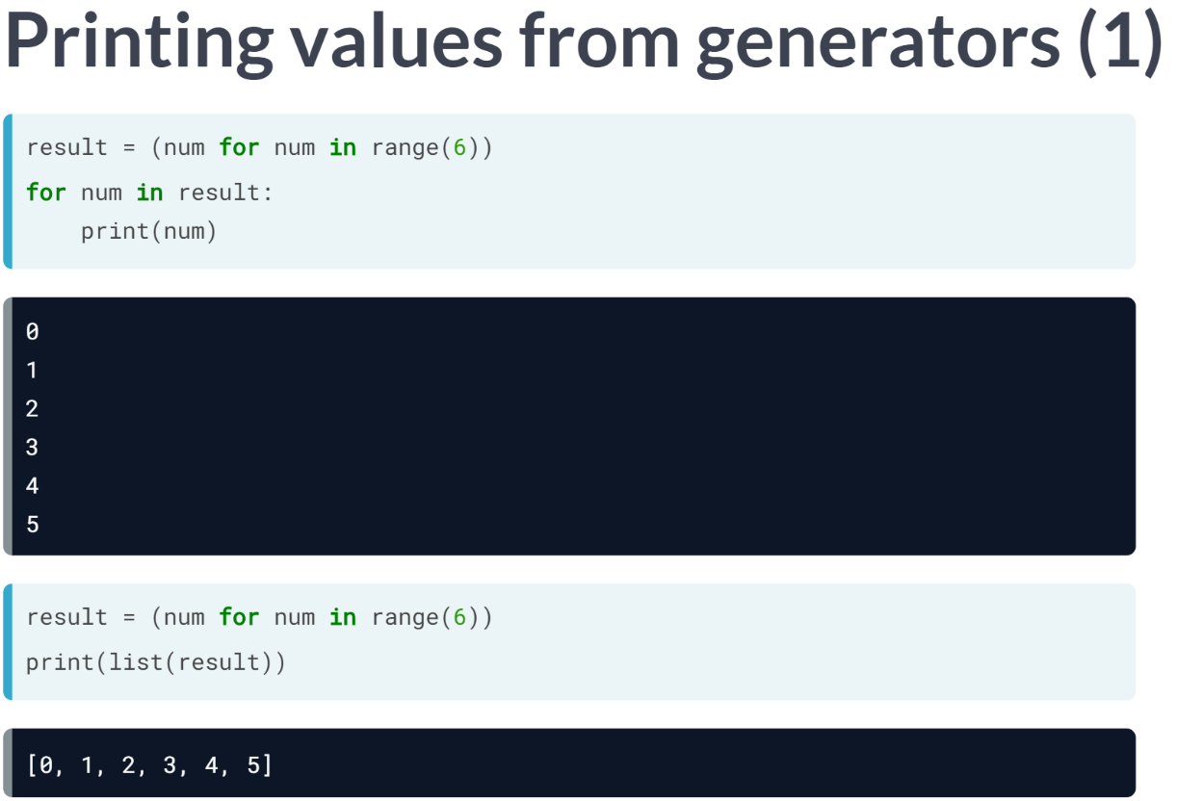  
Here we can see that looping over a generator expression produces the elements of the analogous list. We can also pass a generator to the function list to create the list.  
  
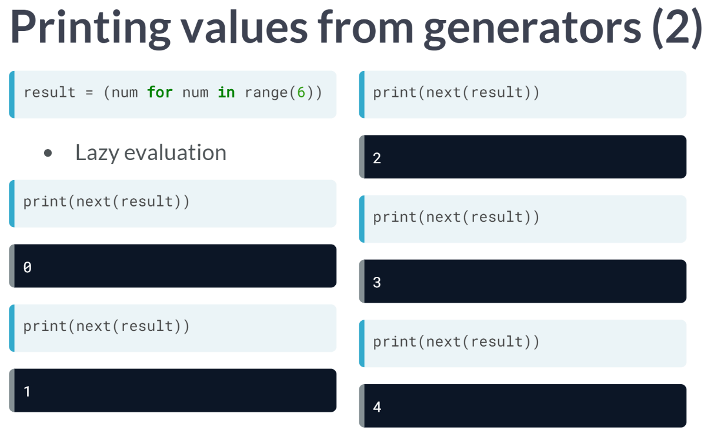  
Moreover, like any other iterator, we can pass a generator to the function next in order to reiterate through its elements. This is something called lazy evaluation, whereby the evaluation of the expression is delayed until its value is needed.

This can help a great deal when working with extremely large sequences as you don't want to store the entire list in memory, which is what comprehensions would do; you want to generate elements of the sequences on the fly.

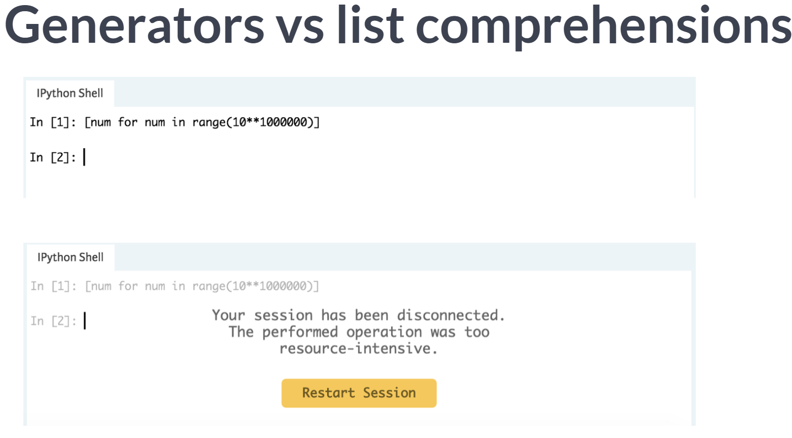

Let's say that we wanted to iterate over a very large sequences of numbers, such as integers from 0 up 10 to the power of million. Look what happens after building such an iterable list using a comprehension on DataCamp's servers, but it is disconnected because the list we are trying to create can't even be stored in memory.

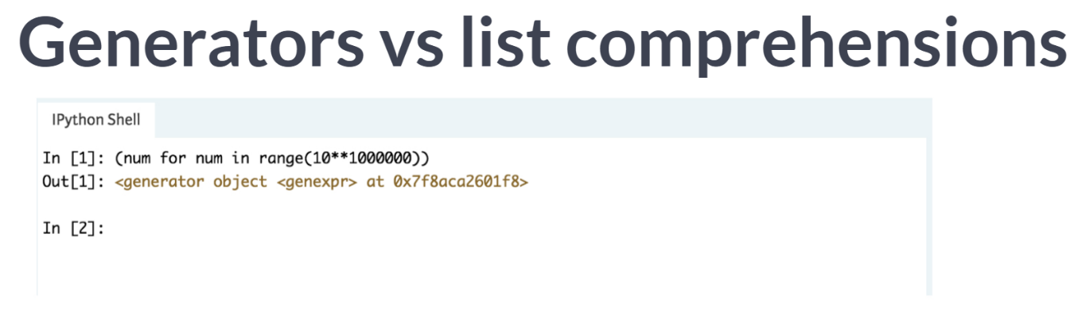  
Check this out, though. We can easily create the analogous generator object because it doesn't yet create the entire list.

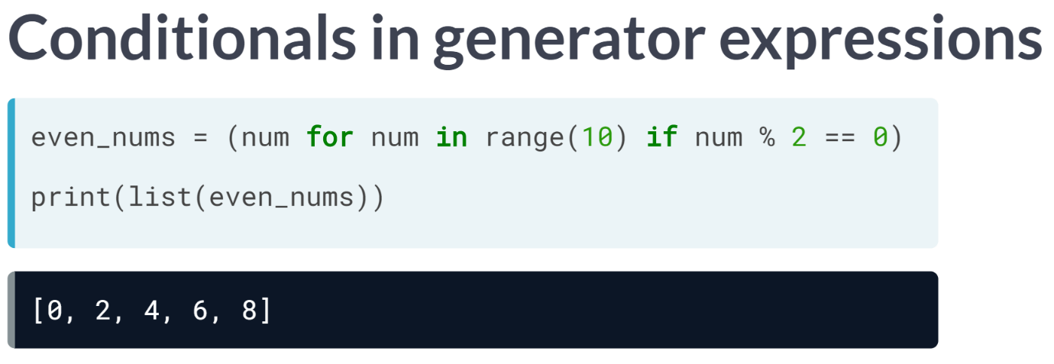  
What's really cool is that anything we can do in a list comprehension such as filtering and applying conditionals, we can also do in a generator expression, such as you see here. You'll get a whole bunch of practice with this in the upcoming exercise.

Let's talk about the ability to write generator functions.  
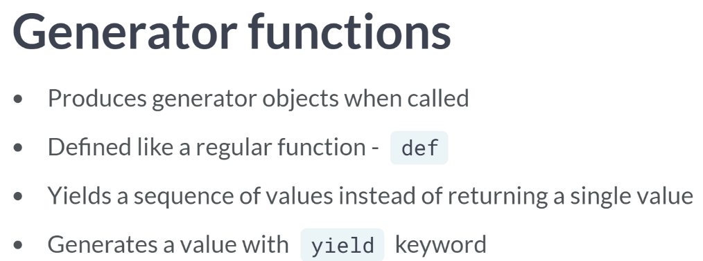  
  
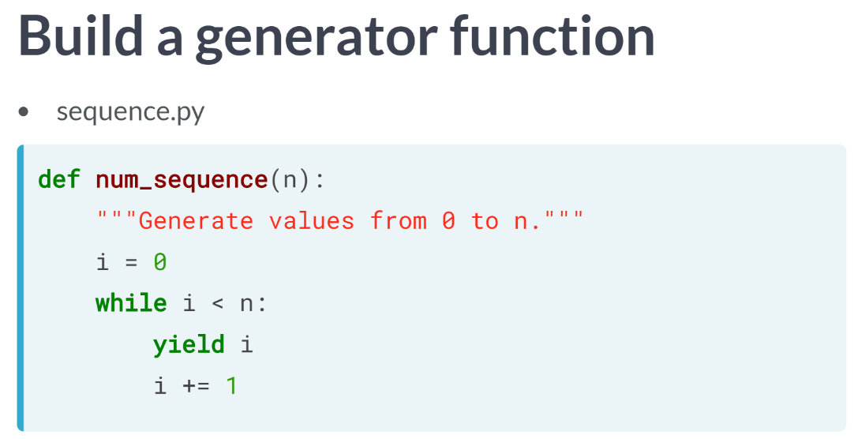  
Here, generation function is defined that when called with a number n, produces a generator object that generates integer 0 through *n*.

We can see within the function definition that *i* is initialize to 0 and that the first time the generator object is called, it yields *i* equal to 0.

It then adds 1 to *i* and will then yield 1 on the next iteration and so on. The while loop is true until *i* equals n and then the generator ceases to yield values.

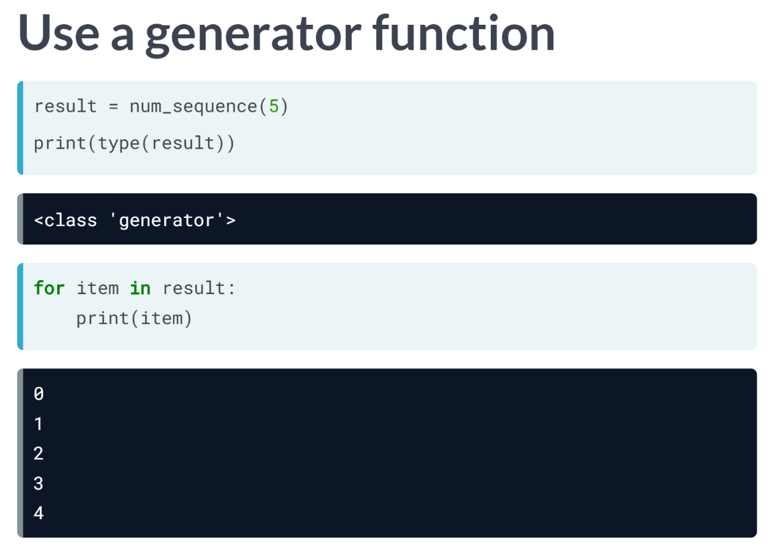  
This generator function can be called as you do any other function. Here we call the generator function with the argument, 5. Using for loop, we can iterate over this generator object with a for loop to print the values it yields.

In short, generator functions are a powerful and customizable way to create generators.

# List comprehensions vs generators

You've seen from the videos that list comprehensions and generator expressions look very similar in their syntax, except for the use of parentheses () in generator expressions and brackets [] in list comprehensions.

In this exercise, you will recall the difference between list comprehensions and generators. To help with that task, the following code has been pre-loaded in the environment:

# List of strings

fellowship = ['frodo', 'samwise', 'merry', 'aragorn', 'legolas', 'boromir', 'gimli']

# List comprehension

fellow1 = [member for member in fellowship if len(member) >= 7]

# Generator expression

fellow2 = (member for member in fellowship if len(member) >= 7)

Try to play around with fellow1 and fellow2 by figuring out their types and printing out their values. Based on your observations and what you can recall from the video, select from the options below the best description for the difference between list comprehensions and generators.

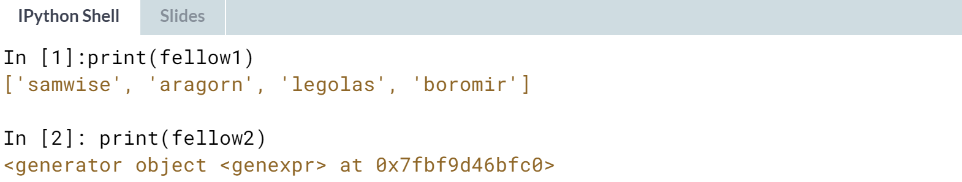

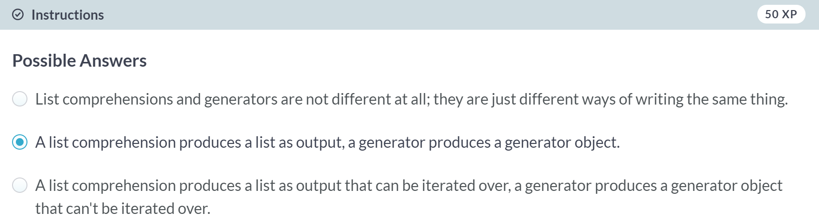

# Write your own generator expressions

You are familiar with what generators and generator expressions are, as well as its difference from list comprehensions. In this exercise, you will practice building generator expressions on your own.

Recall that generator expressions basically have the same syntax as list comprehensions, except that it uses parentheses () instead of brackets []; this should make things feel familiar!

Furthermore, if you have ever iterated over a dictionary with .items(), or used the range() function, for example, you have already encountered and used generators before, without knowing it!

When you use these functions, Python creates generators for you behind the scenes. Now, you will start simple by creating a generator object that produces numeric values.

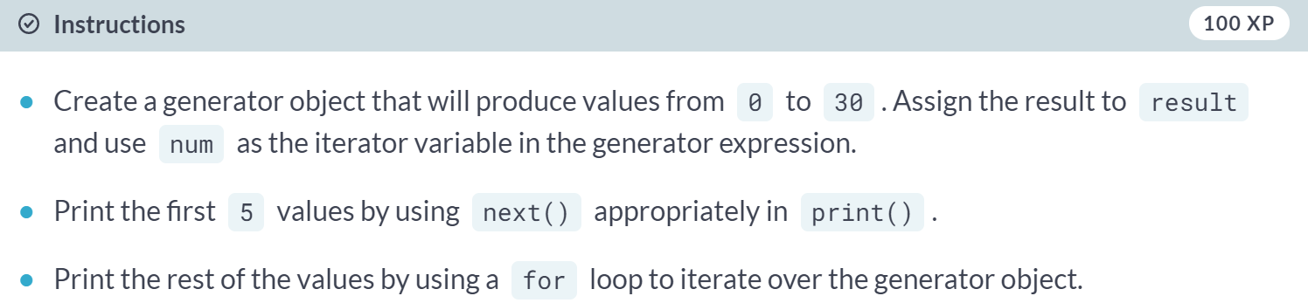

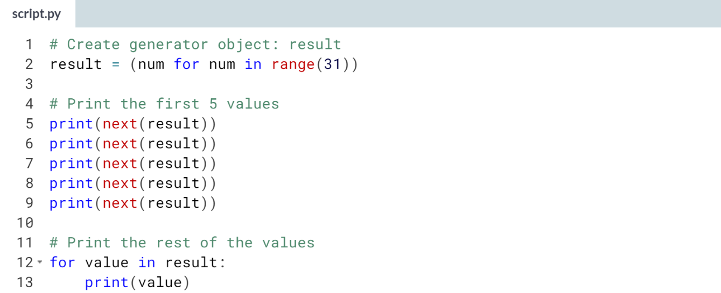  
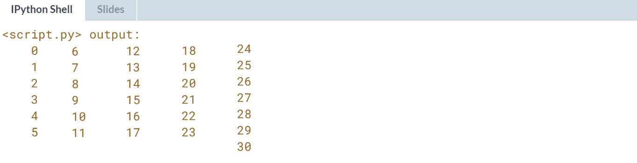

(Result output was arranged vertically, but I arranged them as above to fit them in a page.)

# Changing the output in generator expressions

Great! At this point, you already know how to write a basic generator expression. In this exercise, you will push this idea a little further by adding to the output expression of a generator expression. Because generator expressions and list comprehensions are so alike in syntax, this should be a familiar task for you!

You are given a list of strings lannister and, using a generator expression, create a generator object that you will iterate over to print its values.

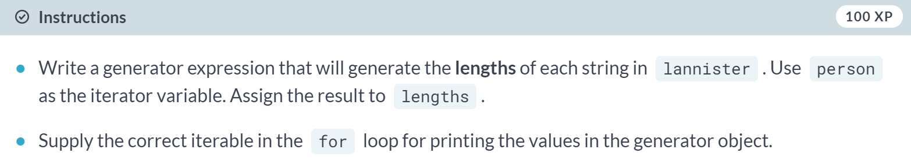  
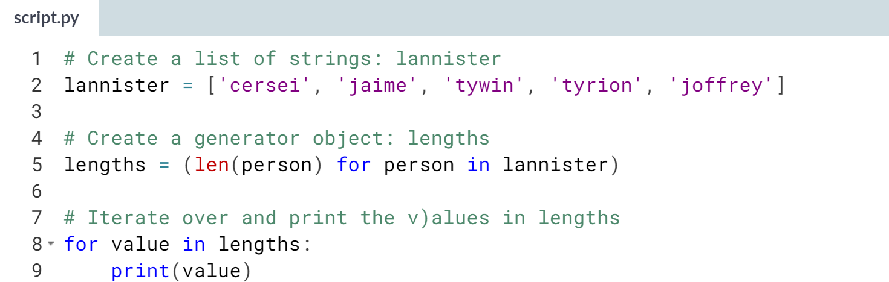

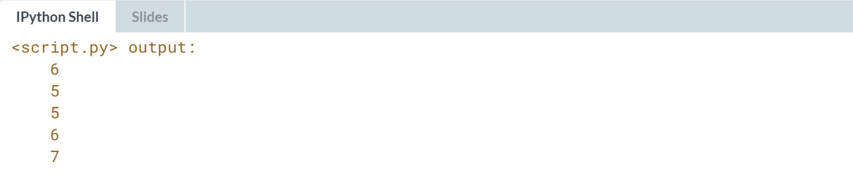

# Build a generator – **REVIEW**

In previous exercises, you've dealt mainly with writing generator expressions, which uses comprehension syntax. Being able to use comprehension syntax for generator expressions made your work so much easier!

Now, recall from the video that not only are there generator expressions, there are generator functions as well. **Generator functions** are functions that, like generator expressions, yield a series of values, instead of returning a single value. A generator function is defined as you do a regular function, but whenever it generates a value, it uses the keyword yield instead of return.

In this exercise, you will create a generator function with a similar mechanism as the generator expression you defined in the previous exercise:

lengths = (len(person) for person in lannister)

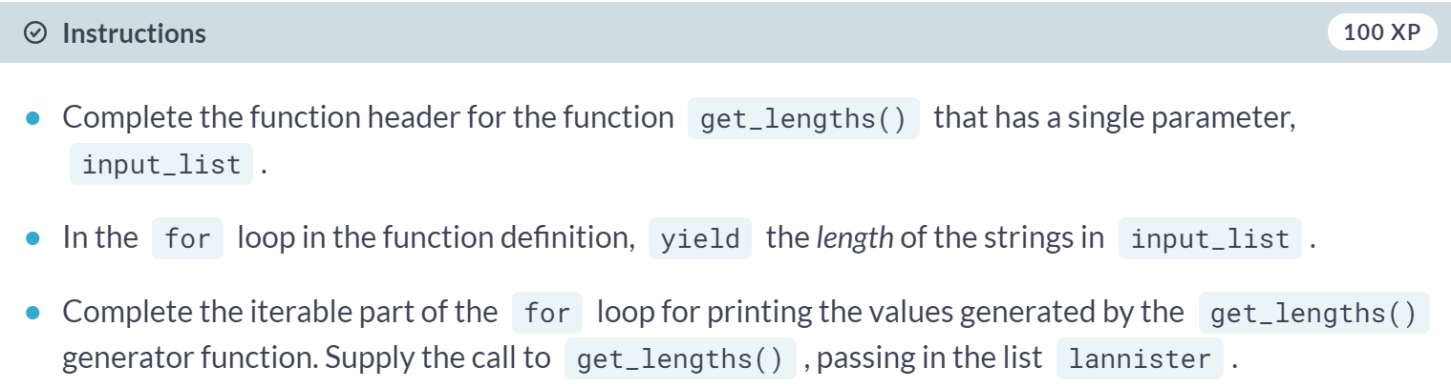  
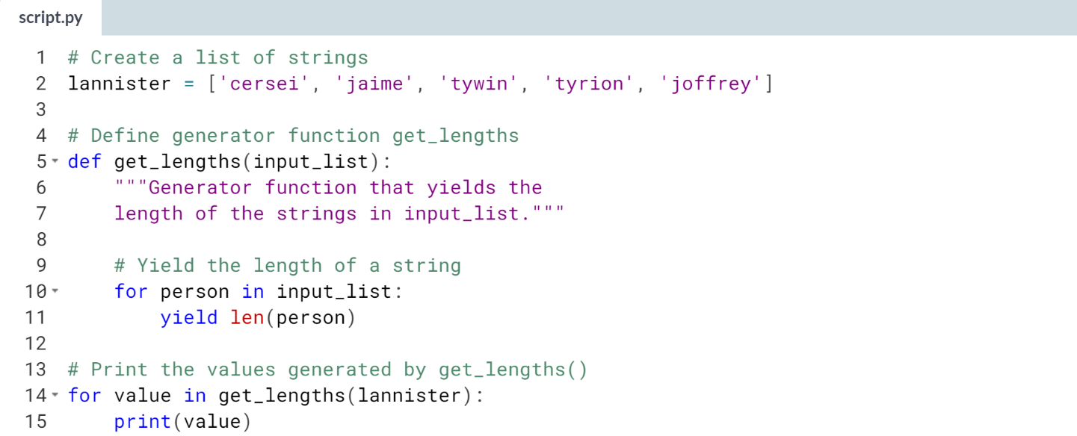  
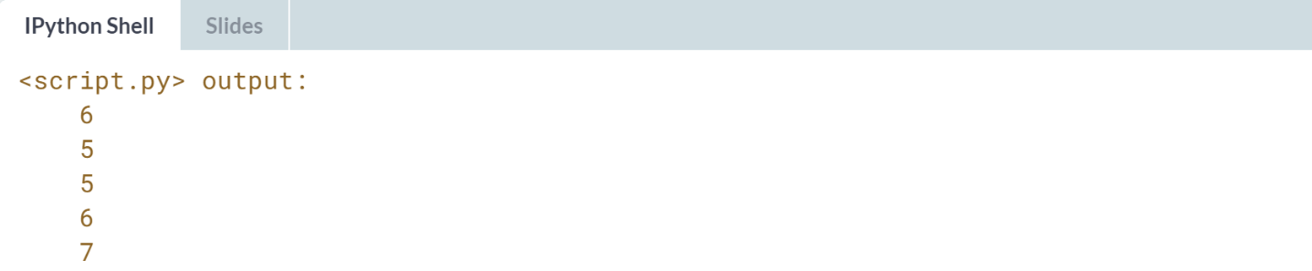



In the following exercise, we will use list comprehension to wrangle important information from the time-stamped data of real tweets. Let's remind ourselves the structure and syntax of a list comprehension.

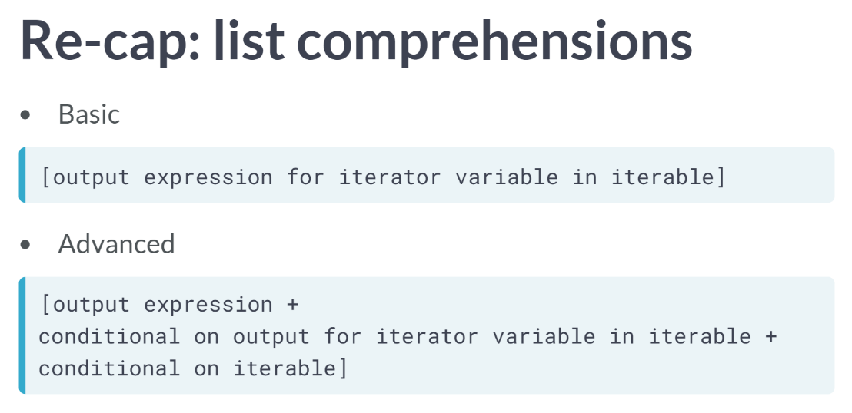

In its most basic form, it is enclosed in square brackets and is structured as output expression for iterator variable in iterable.

More advanced comprehensions can include conditionals on the output expression and/or conditionals on the iterable.

# List comprehensions for time-stamped data

You will now make use of what you've learned from this chapter to solve a simple data extraction problem. You will also be introduced to a data structure, the pandas **Series**, in this exercise.

We won't elaborate on it much here, but what you should know is that it is a data structure that you will be working with a lot of times when analyzing data from pandas DataFrames. You can think of DataFrame columns as single-dimension arrays called Series.

In this exercise, you will be using a list comprehension to extract the time from time-stamped Twitter data. The pandas package has been imported as pd and the file 'tweets.csv' has been imported as the df DataFrame for your use.

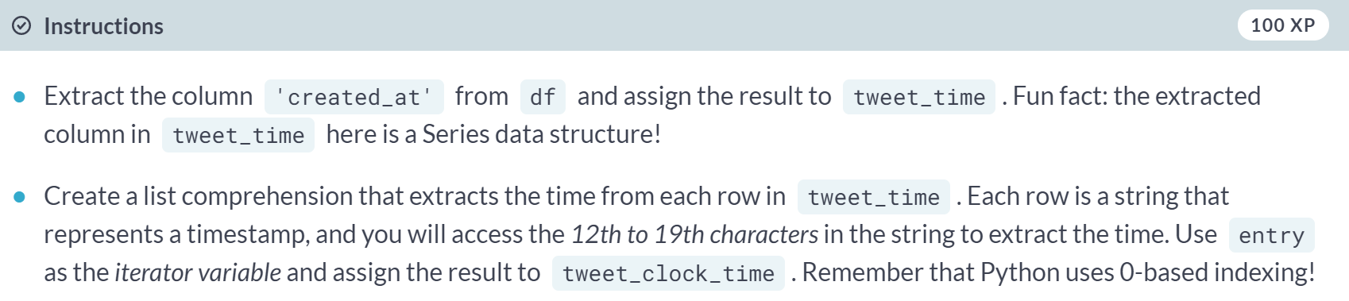

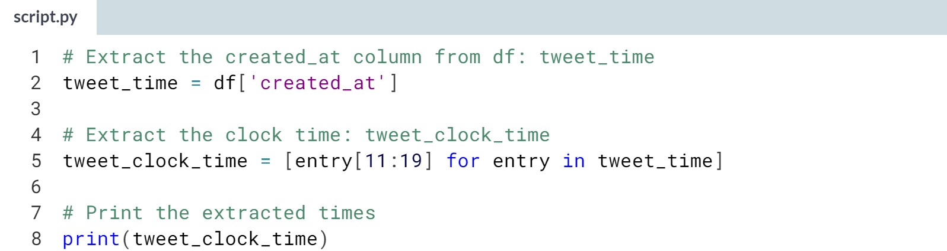  
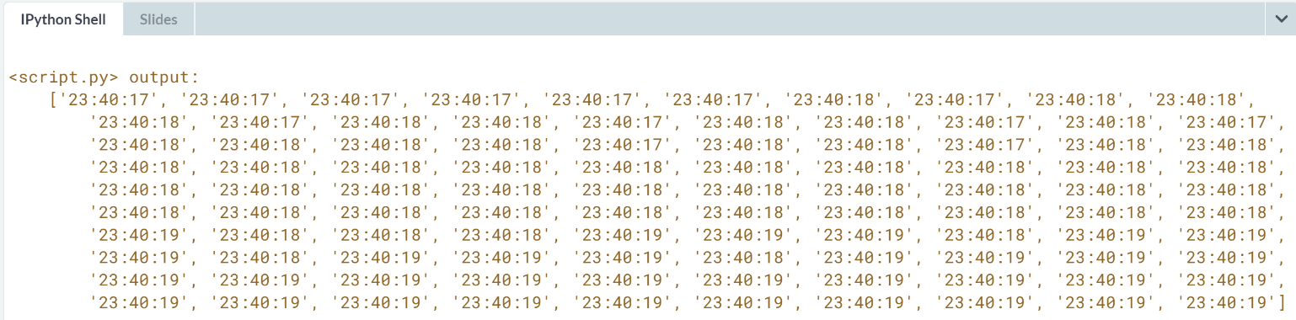

# Conditional list comprehensions for time-stamped data

Great, you've successfully extracted the data of interest, the time, from a pandas DataFrame! Let's tweak your work further by adding a conditional that further specifies which entries to select.

In this exercise, you will be using a list comprehension to extract the time from time-stamped Twitter data. You will add a conditional expression to the list comprehension so that you only select the times in which entry[17:19] is equal to '19'. The pandas package has been imported as pd and the file 'tweets.csv' has been imported as the df DataFrame for your use.

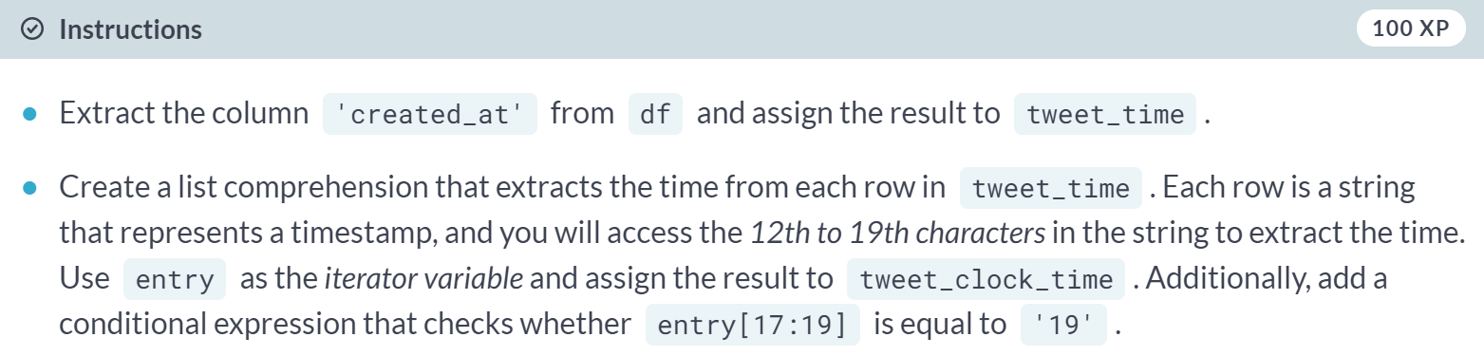

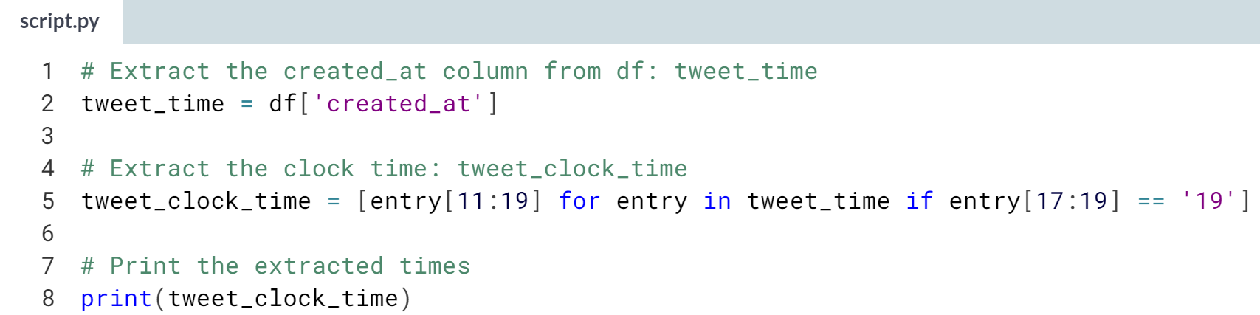

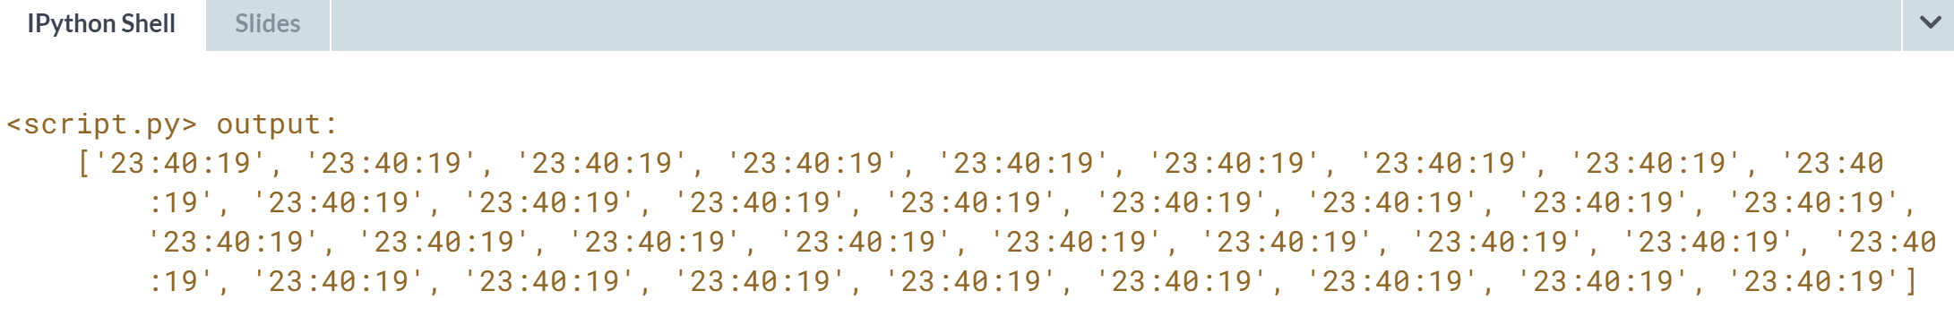

**3. Bringing it all together!**

This chapter will allow you to apply your newly acquired skills toward wrangling and extracting meaningful information from a real-world dataset—the World Bank's World Development Indicators. You'll have the chance to write your own functions and list comprehensions as you work with iterators and generators to solidify your Python data science chops.



In this chapter, you'll use your recently gained skills of writing user-defined functions, iterators, list comprehensions and generators to wrangle and extract meaningful information from a real-world data set, the World Bank World Development dataset.

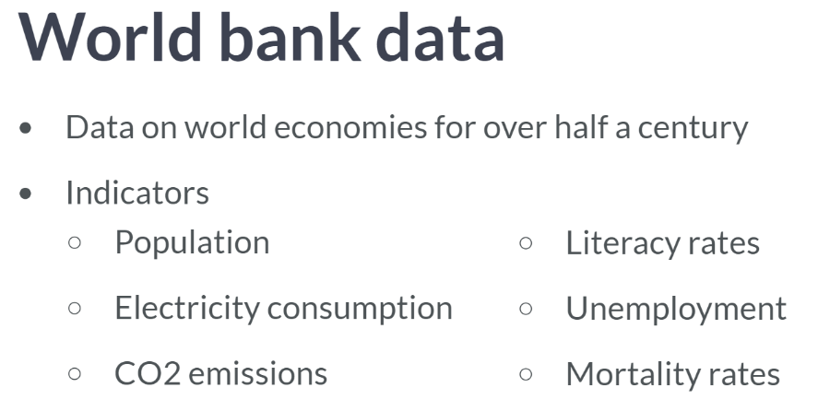  
This dataset contains data on 217 world economies for over half a century, from 1960 up until 2015. The data contains hundreds of indicators from population, electricity consumption, and CO2 emission to literacy rates, unemployment, and mortality rates.  
  
In the following exercises, you will use dictionaries, zipping, user-defined functions, and list comprehensions to wrangle some of this wonderfully rich dataset. Let's quickly recap these tools:

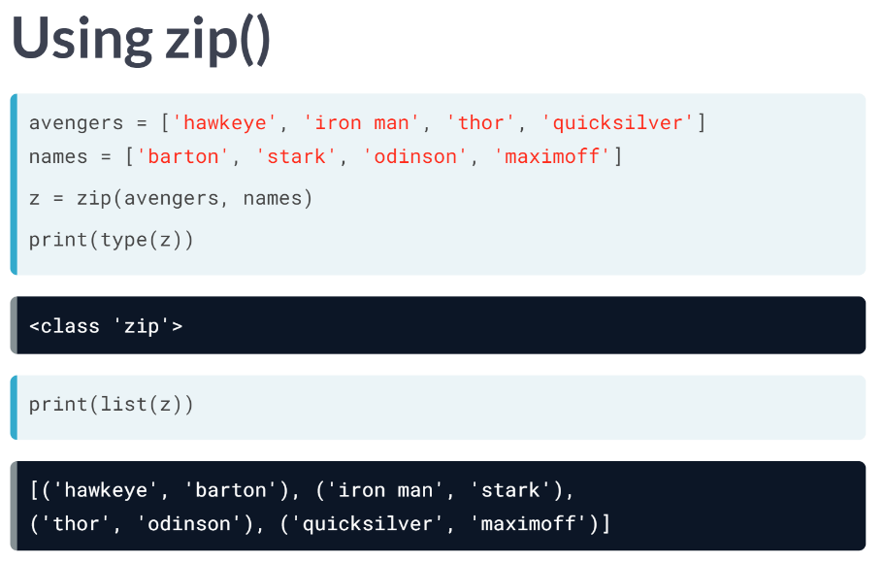  
The ***zip()*** function accepts an arbitrary number of iterables and returns an iterator of tuples. We bring back our two lists from before, one of the avengers, the other of their names. Passing these to the zip function creates a zip object, which is an iterator of tuples. We can turn them into a list and then print this list.

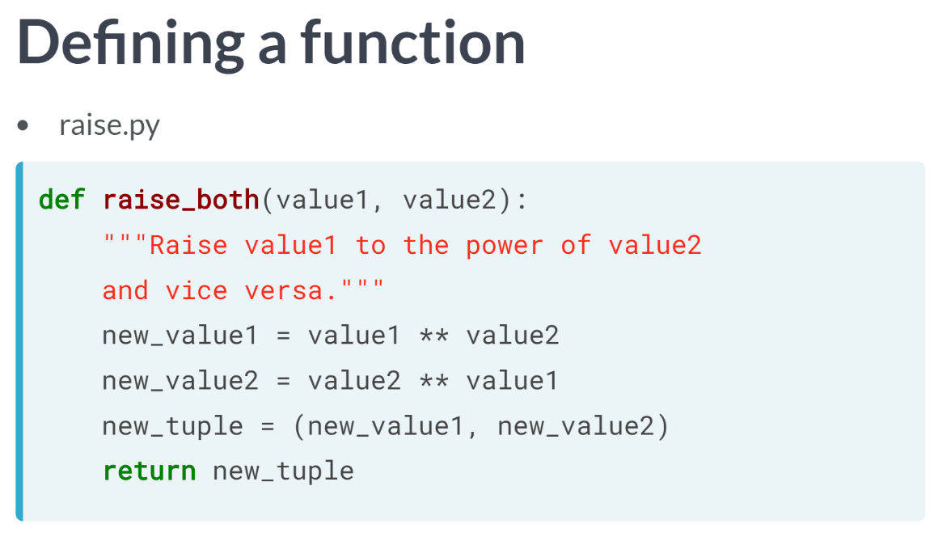  
For writing functions, function headers begin with the keyword def, followed by the function name, arguments inside parentheses and a colon. We then have the function body, with the docstrings enclosed in triple quotation marks.

The rest of the function body performs the computation that the function does and closes with the keyword return, followed by the value or values to return.

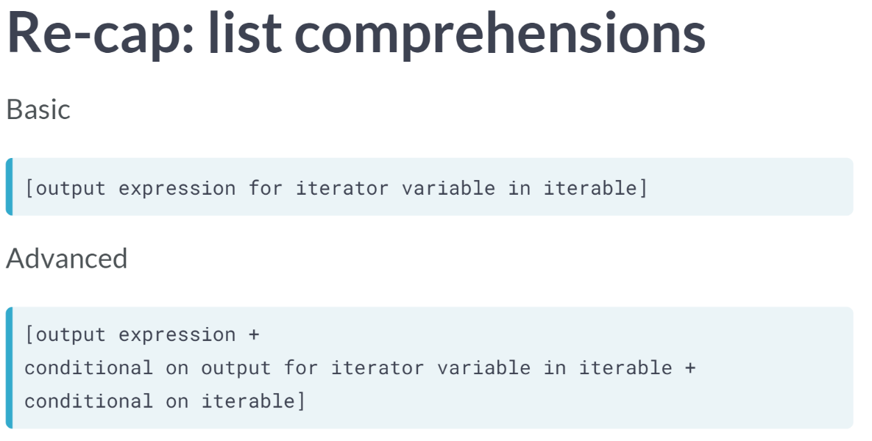  
Comprehensions, in their most basic forms, are enclosed in square brackets and are structured as output expression for iterator variable in iterable.

More advanced comprehensions can include conditionals on the output expression and/or conditionals on the iterable.

# Dictionaries for data science

For this exercise, you'll use what you've learned about the zip() function and combine two lists into a dictionary.

These lists are actually extracted from a [**bigger dataset file of world development indicators from the World Bank.**](http://data.worldbank.org/data-catalog/world-development-indicators) For pedagogical purposes, we have pre-processed this dataset into the lists that you'll be working with.

The first list feature_names contains header names of the dataset and the second list row_vals contains actual values of a row from the dataset, corresponding to each of the header names.

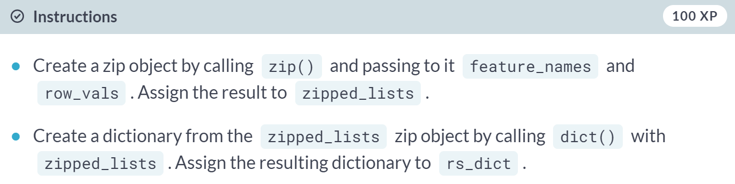  
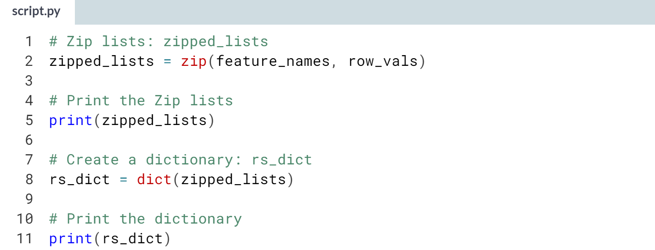  
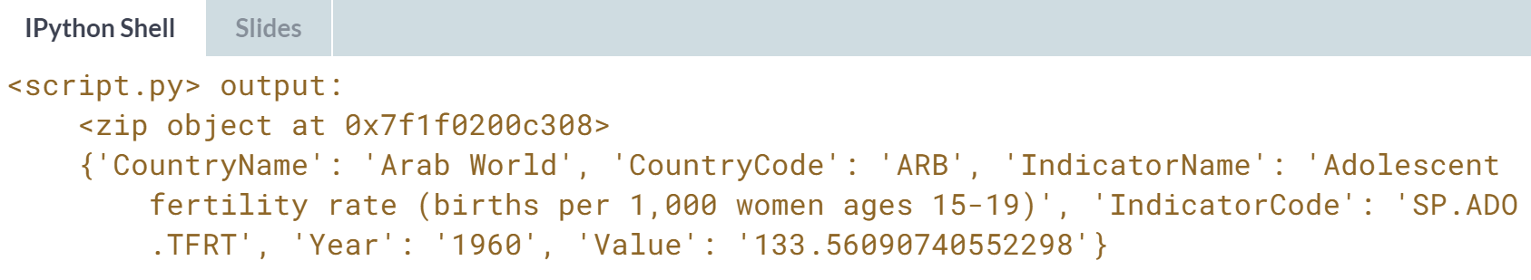

# Writing a function to help you

Suppose you needed to repeat the same process done in the previous exercise to many, many rows of data. Rewriting your code again and again could become very tedious, repetitive, and unmaintainable.

In this exercise, you will create a function to house the code you wrote earlier to make things easier and much more concise. Why? This way, you only need to call the function and supply the appropriate lists to create your dictionaries! Again, the lists feature_names and row_vals are preloaded and these contain the header names of the dataset and actual values of a row from the dataset, respectively.

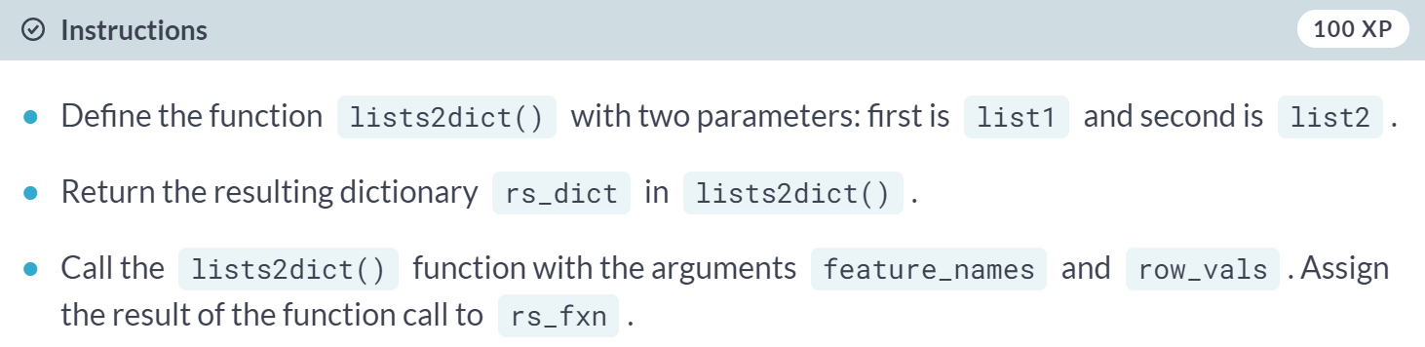  
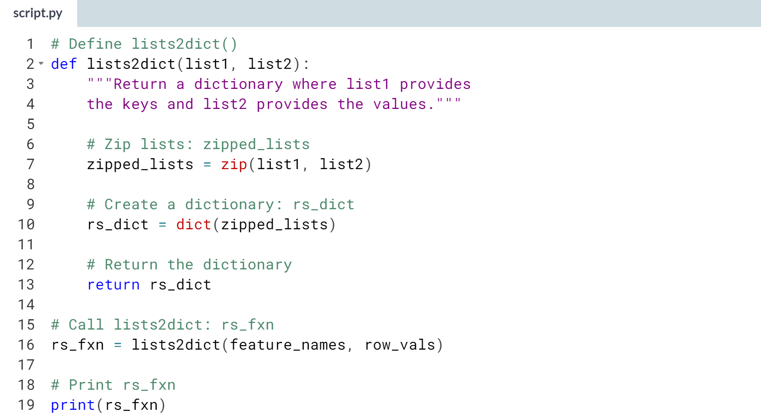  
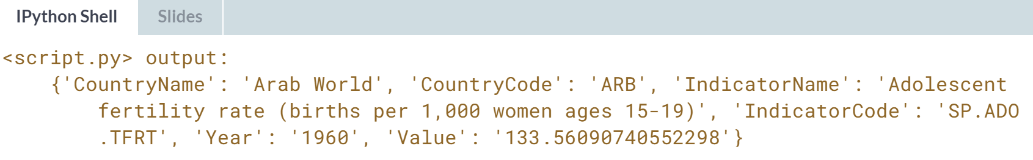

# Using a list comprehension

This time, you're going to use the lists2dict() function you defined in the last exercise to turn a bunch of lists into a list of dictionaries with the help of a list comprehension.

The lists2dict() function has already been preloaded, together with a couple of lists, feature_names and row_lists. feature_names contains the header names of the World Bank dataset and row_lists is a list of lists, where each sublist is a list of actual values of a row from the dataset.

Your goal is to use a list comprehension to generate a list of dicts, where the keys are the header names and the values are the row entries.

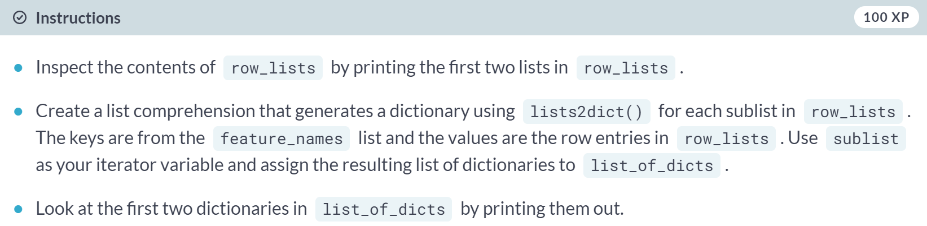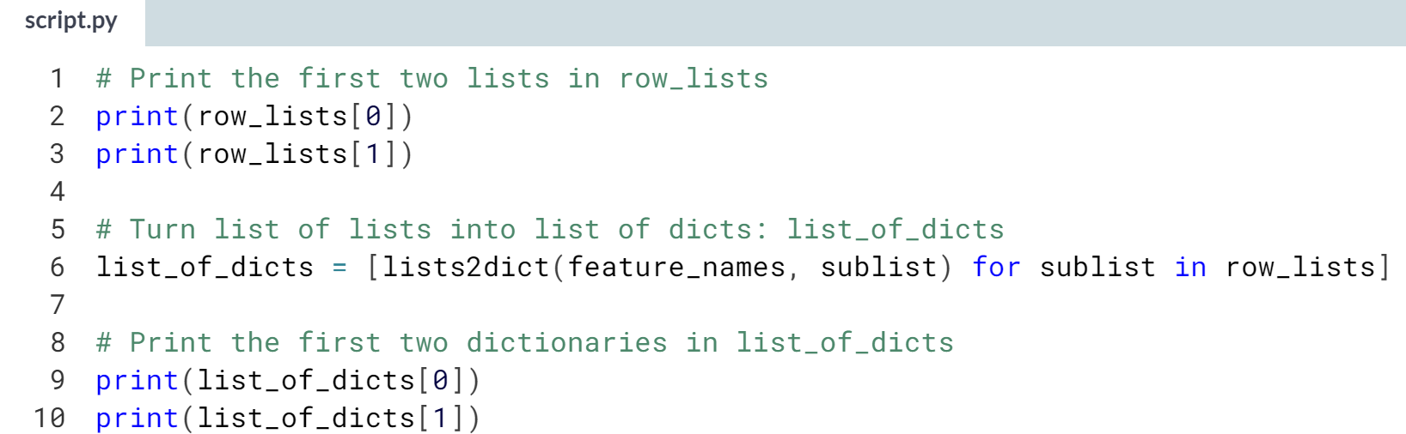

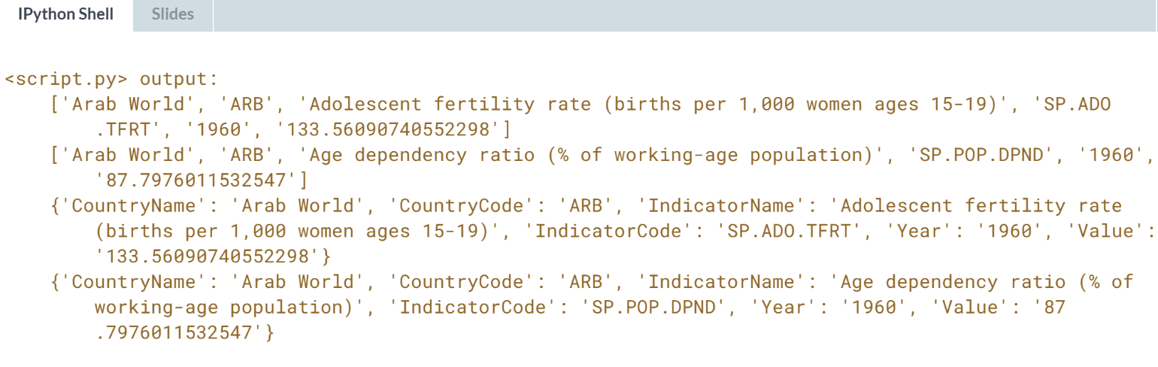

# Turning this all into a DataFrame

You've zipped lists together, created a function to house your code, and even used the function in a list comprehension to generate a list of dictionaries. That was a lot of work and you did a great job!

You will now use of all these to convert the list of dictionaries into a pandas DataFrame. You will see how convenient it is to generate a DataFrame from dictionaries with the DataFrame() function from the pandas package.

The lists2dict() function, feature_names list, and row_lists list have been preloaded for this exercise.

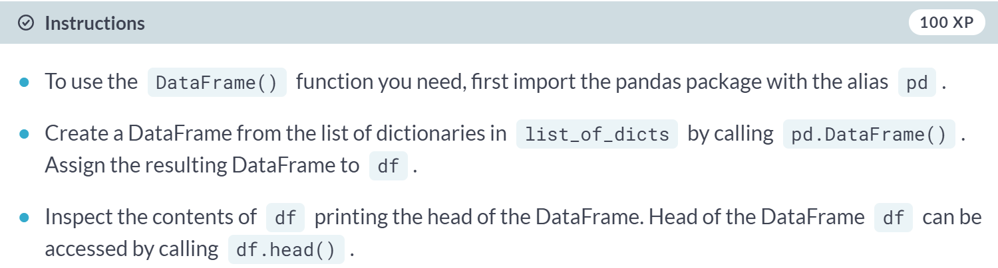  
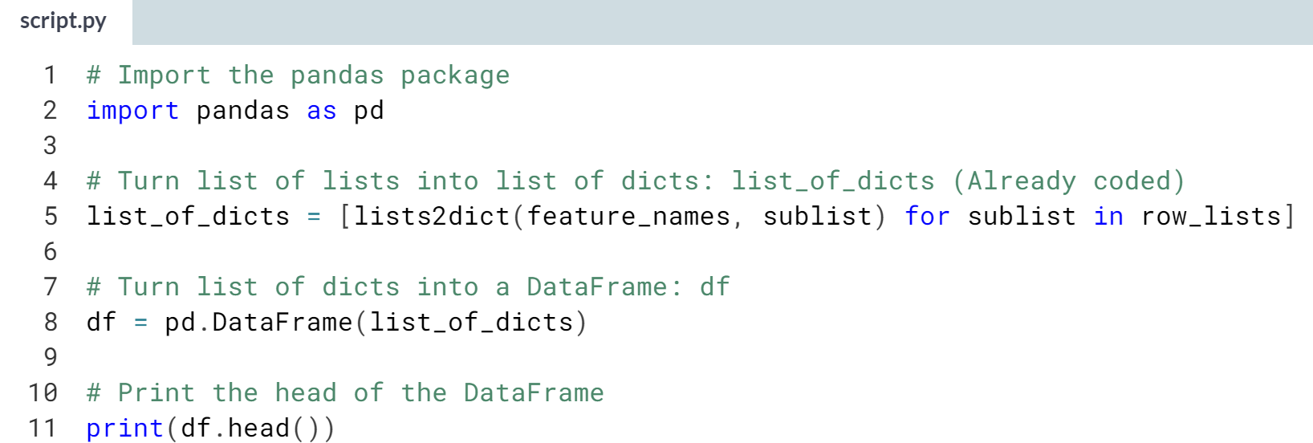  
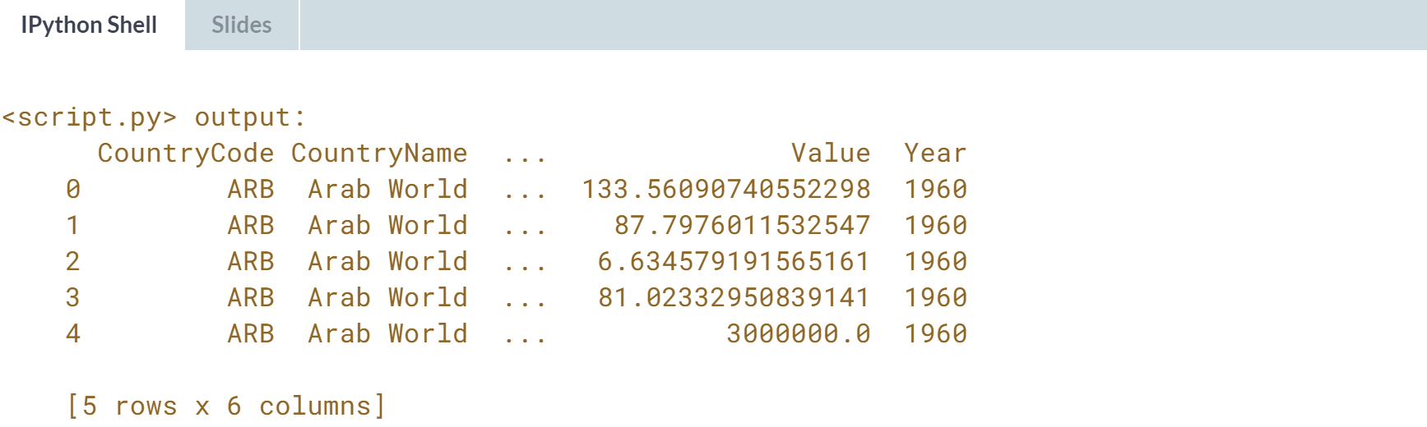



Let's take a step back and look at importing the dataset, which is pretty large. We already saw that for a large dataset, we can use an iterator to load it in chunks.

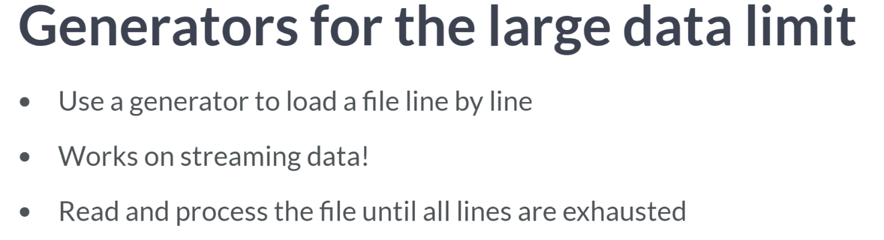  
We can also write a generator to load it in line by line and one of the really cool things about this method is that if the data is streaming, that is, if new lines are being written to the file you are reading, this method will keep on reading and processing the file until there are no lines left for it to read.

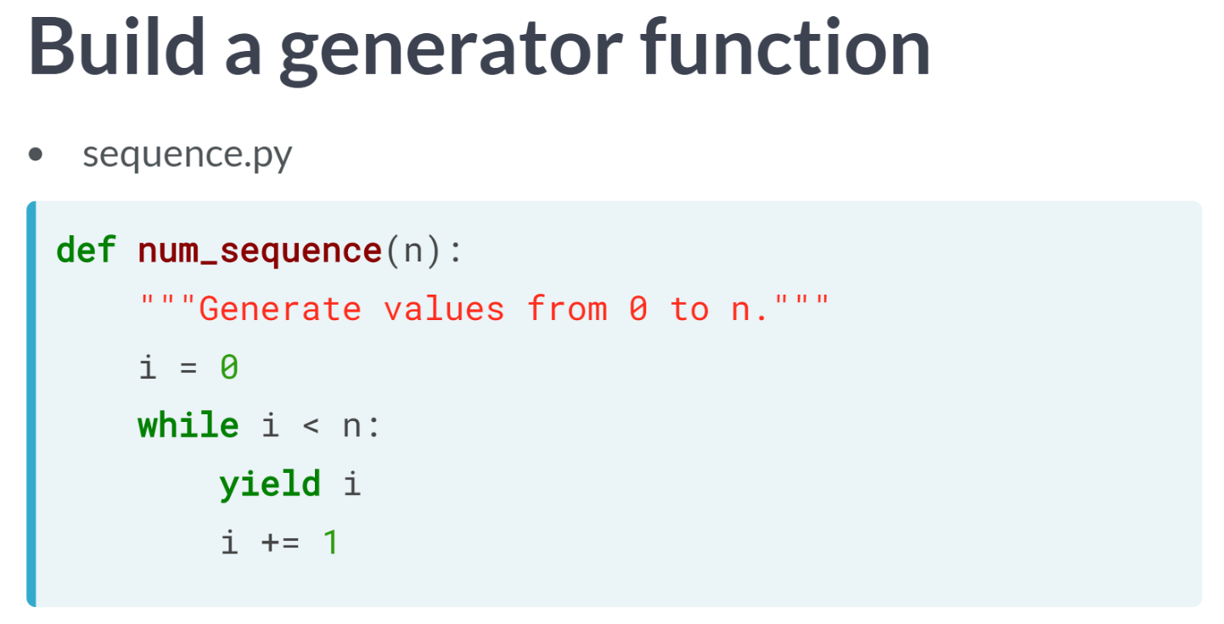  
We will be writing a generator function that can process large amounts of data, so let me remind you of our typical example of a generator function: here is a generator function that, when called with a number n, produces a generator object that generates integers 0 through n. In the function definition, i is initialized to 0.

The first time the generator object is called, it yields *i* equal to 0. It then adds one to *i* and will then yield one on the next iteration and so on. The while loop is true until *i* equals n and then the generator ceases to yield values.

In the exercises, we will be writing a generator function that, on each iteration, reads a new line of the file.

# Processing data in chunks (1) – **REVIEW**

Sometimes, data sources can be so large in size that storing the entire dataset in memory becomes too resource intensive. In this exercise, you will process the first 1000 rows of a file line by line, to create a dictionary of the counts of how many times each country appears in a column in the dataset.

The csv file 'world_dev_ind.csv' is in your current directory for your use. To begin, you need to open a connection to this file using what is known as a context manager. For example, the command with open('datacamp.csv') as datacamp binds the csv file 'datacamp.csv' as datacamp in the context manager. Here, the with statement is the context manager, and its purpose is to ensure that resources are efficiently allocated when opening a connection to a file.

If you'd like to learn more about context managers, refer [**DataCamp course on Importing Data in Python.**](https://www.datacamp.com/courses/importing-data-in-python-part-1)

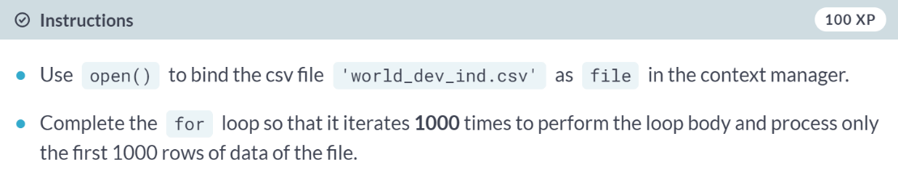  
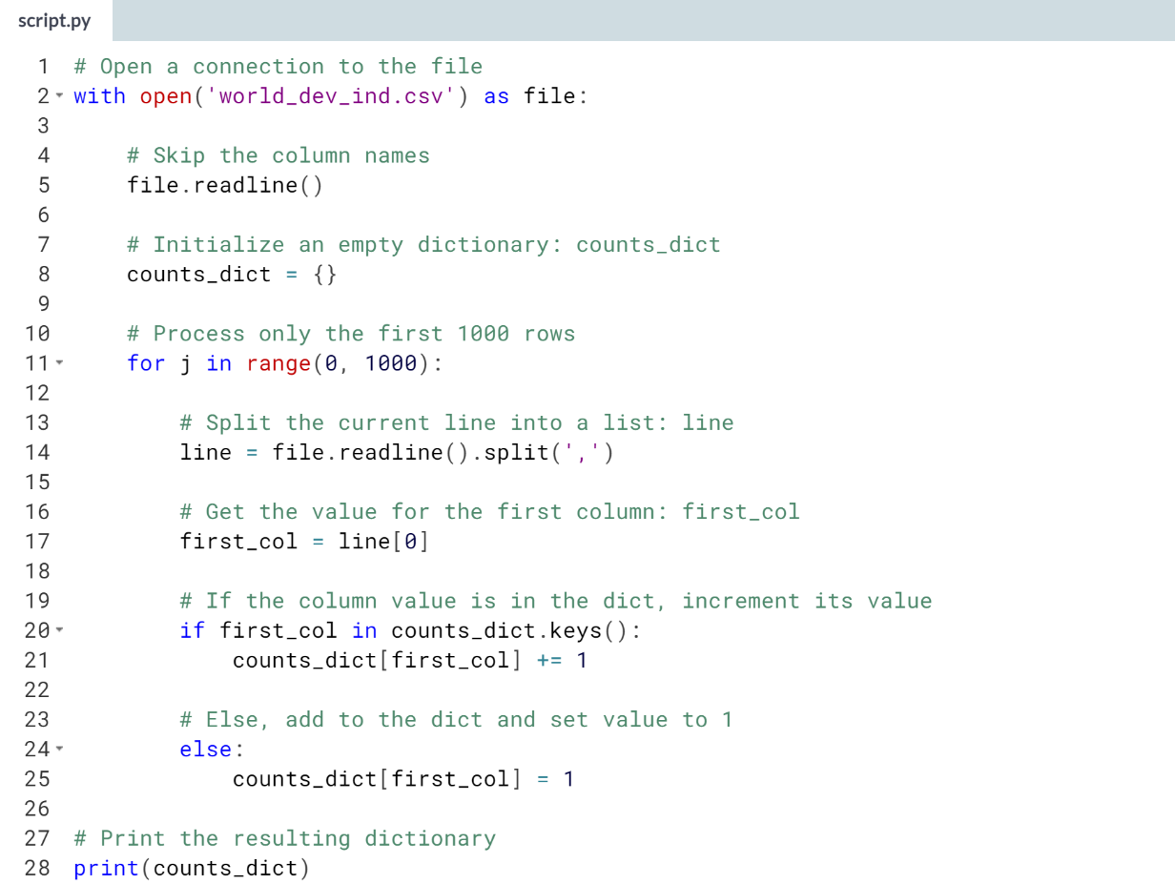  
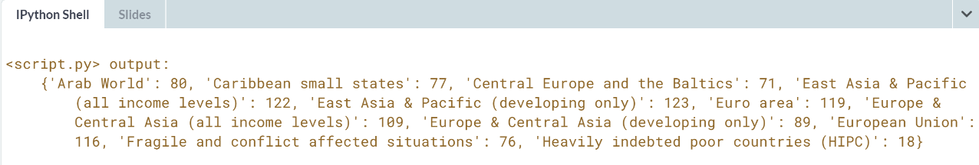

# Writing a generator to load data in chunks (2)

In the previous exercise, you processed a file line by line for a given number of lines. What if, however, you want to do this for the entire file?

In this case, it would be useful to use **generators**. Generators allow users to [**lazily evaluate data**](http://www.blog.pythonlibrary.org/2014/01/27/python-201-an-intro-to-generators/). This concept of lazy evaluation is useful when you have to deal with very large datasets because it lets you generate values in an efficient manner by yielding only chunks of data at a time instead of the whole thing at once.

In this exercise, you will define a generator function read_large_file() that produces a generator object which yields a single line from a file each time next() is called on it. The csv file 'world_dev_ind.csv' is in your current directory for your use.

Note that when you open a connection to a file, the resulting file object is already a generator! So out in the wild, you won't have to explicitly create generator objects in cases such as this. However, for pedagogical reasons, we are having you practice how to do this here with the read_large_file() function.

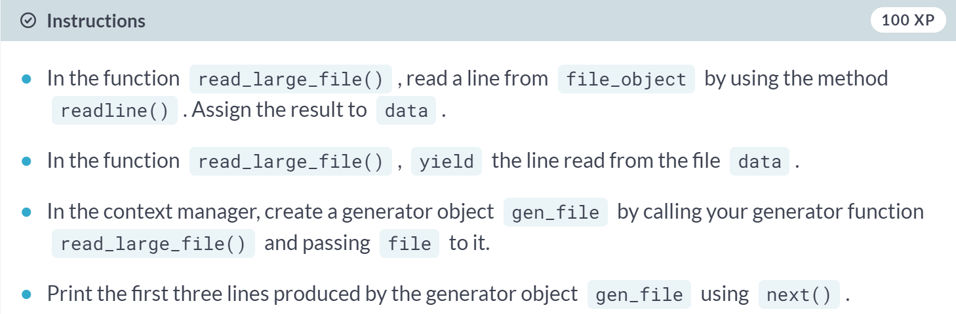

(code on the next page)

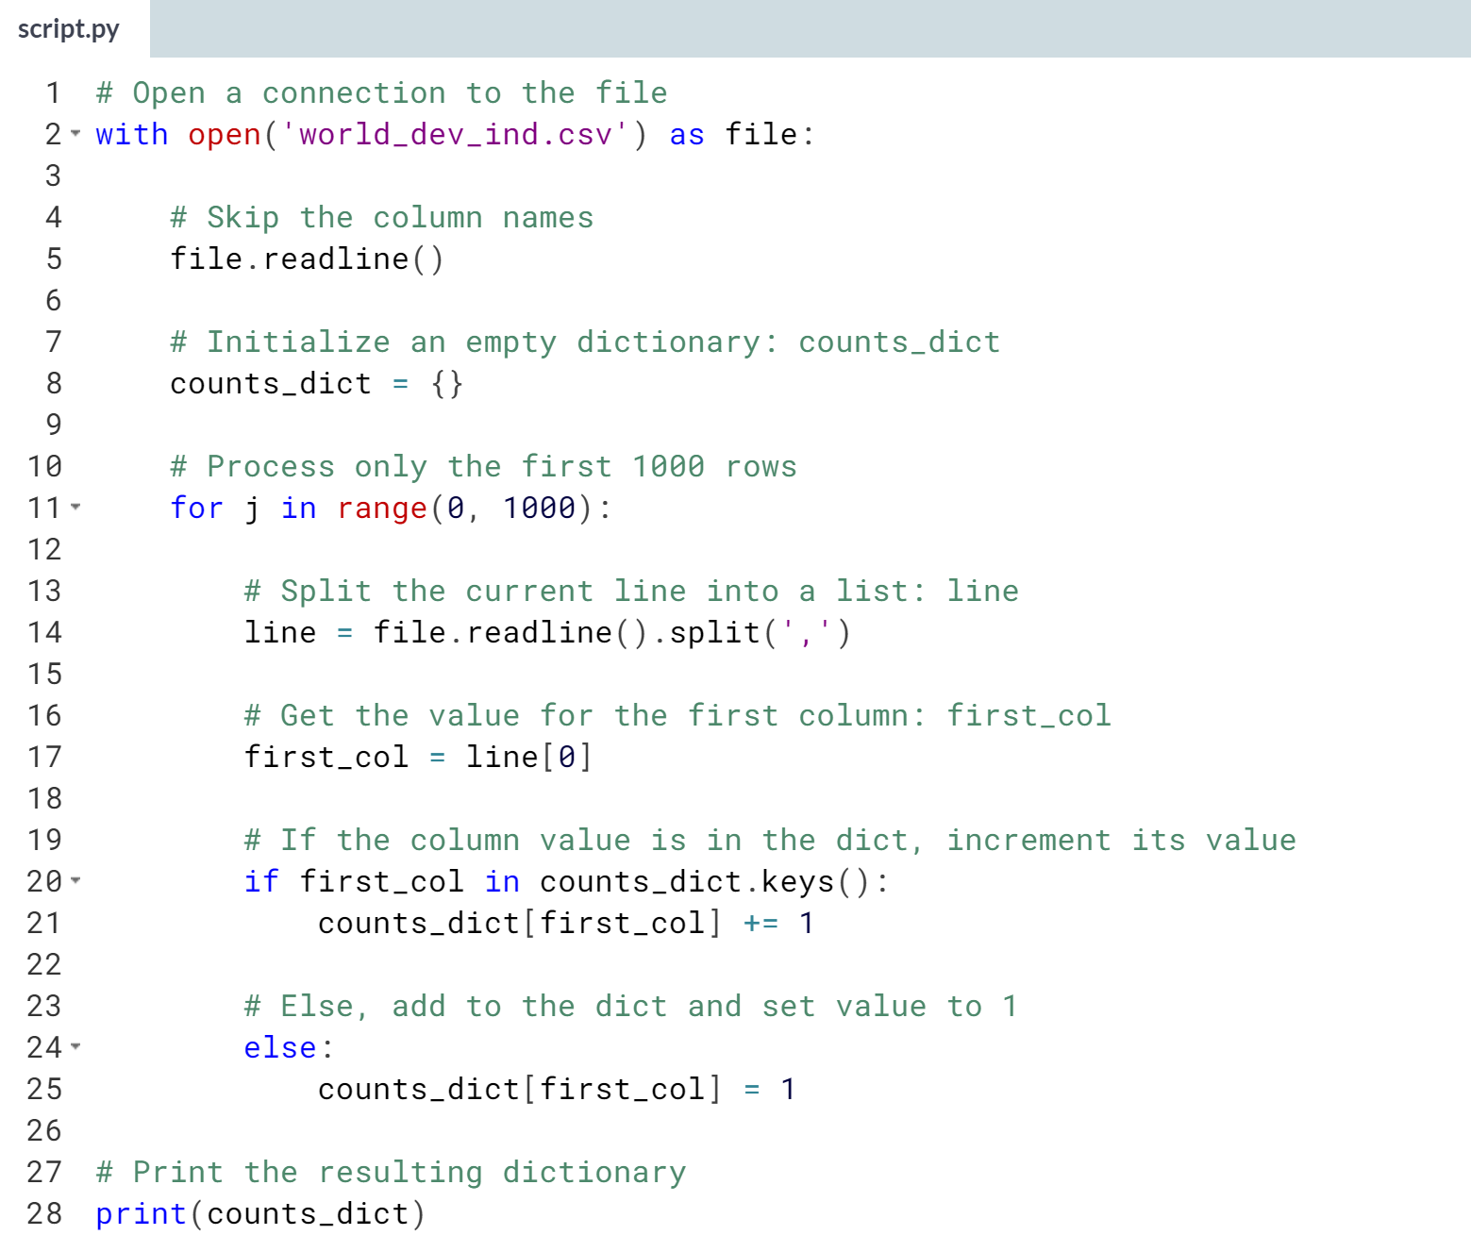

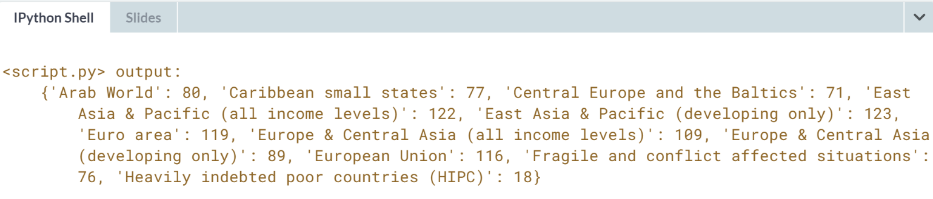  
Wonderful work! Note that since a file object is already a generator, you don't have to explicitly create a generator object with your ***read_large_file()*** function. However, it is still good to practice how to create generators - well done!

# Writing a generator to load data in chunks (3)

Great! You've just created a generator function that you can use to help you process large files.

Now let's use your generator function to process the World Bank dataset like you did previously. You will process the file line by line, to create a dictionary of the counts of how many times each country appears in a column in the dataset. For this exercise, however, you won't process just 1000 rows of data, you'll process the entire dataset!

The generator function read_large_file() and the csv file 'world_dev_ind.csv' are preloaded and ready for your use. Go for it!

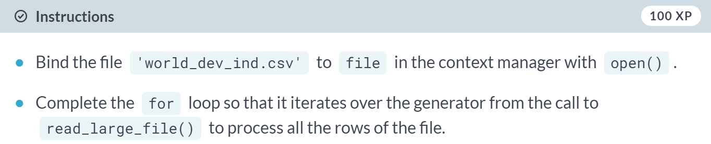  
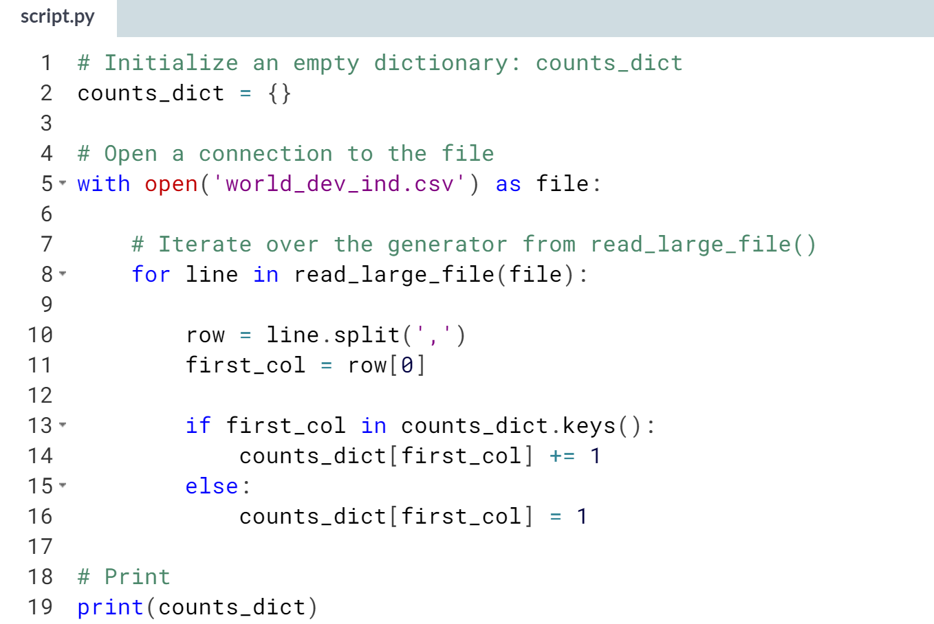  
(Results omitted for redundancy reason – format looks similar to previous exercise)

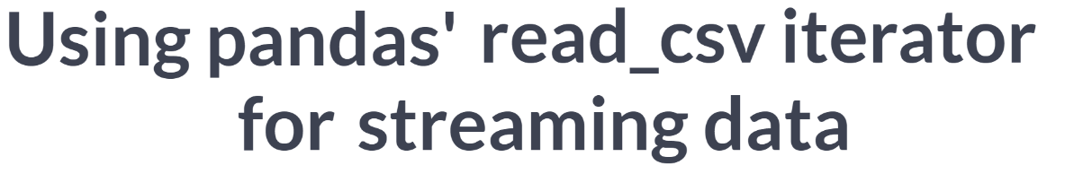

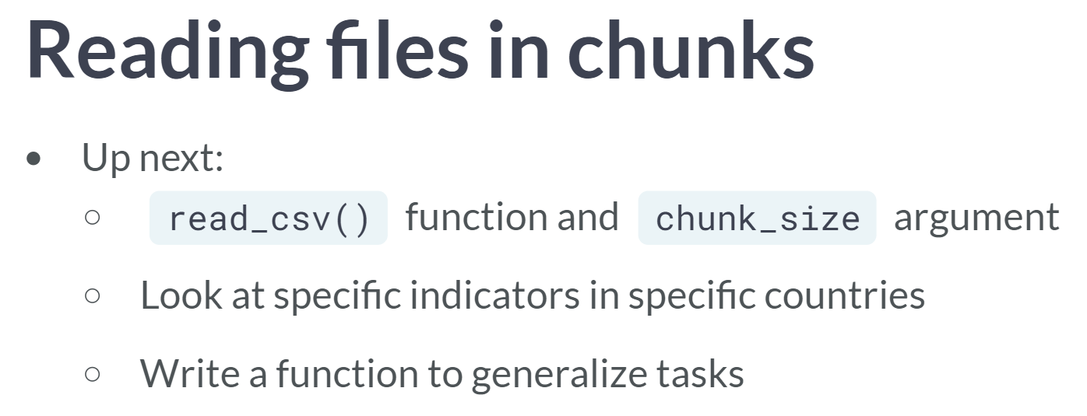

In the remaining exercises, we will revisit the pandas unction ***read_csv()***, along with its chunk_size argument to read in the World Indicator data in chunks, process each chunk and aggregate.

Herein, you will do so in order to look at specific indicators in specific countries and to plot the results over all the years for which the relevant data exists.

You will try your hand at writing a function to perform the same task, which will save so much work when you want to look at the data for a different country.

# Writing an iterator to load data in chunks (1)

Another way to read data too large to store in memory in chunks is to read the file in as DataFrames of a certain length, say, 100. For example, with the pandas package (imported as pd), you can do pd.read_csv(filename, chunksize=100). This creates an iterable **reader object**, which means that you can use next() on it.

In this exercise, you will read a file in small DataFrame chunks with read_csv(). You're going to use the World Bank Indicators data 'ind_pop.csv', available in your current directory, to look at the urban population indicator for numerous countries and years.

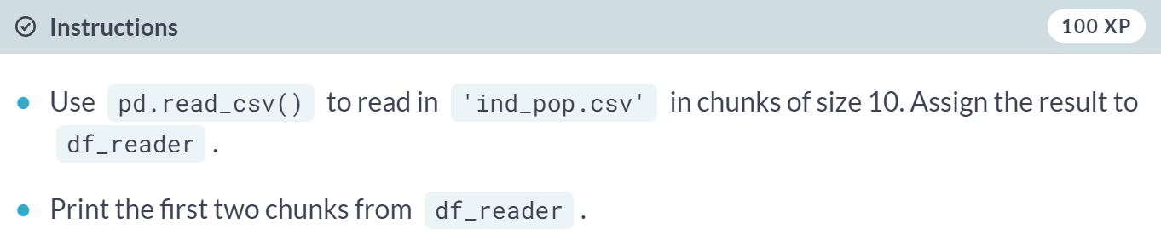

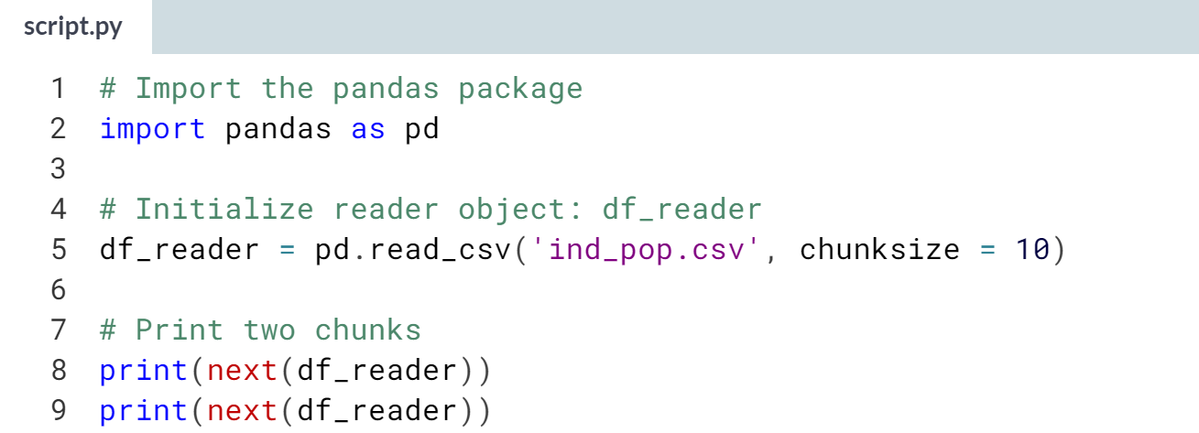  
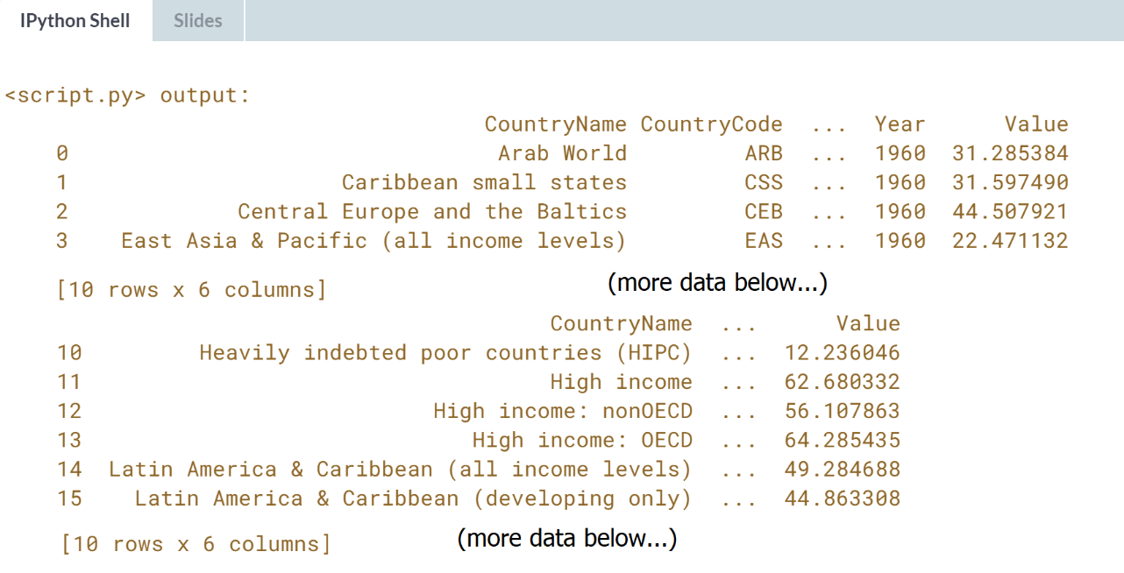

# Writing an iterator to load data in chunks (2)

In the previous exercise, you used read_csv() to read in DataFrame chunks from a large dataset. In this exercise, you will read in a file using a bigger DataFrame chunk size and then process the data from the first chunk.

To process the data, you will create another DataFrame composed of only the rows from a specific country. You will then zip together two of the columns from the new DataFrame, 'Total Population' and 'Urban population (% of total)'. Finally, you will create a list of tuples from the zip object, where each tuple is composed of a value from each of the two columns mentioned.

You're going to use the data from 'ind_pop_data.csv', available in your current directory. Pandas has been imported as pd.

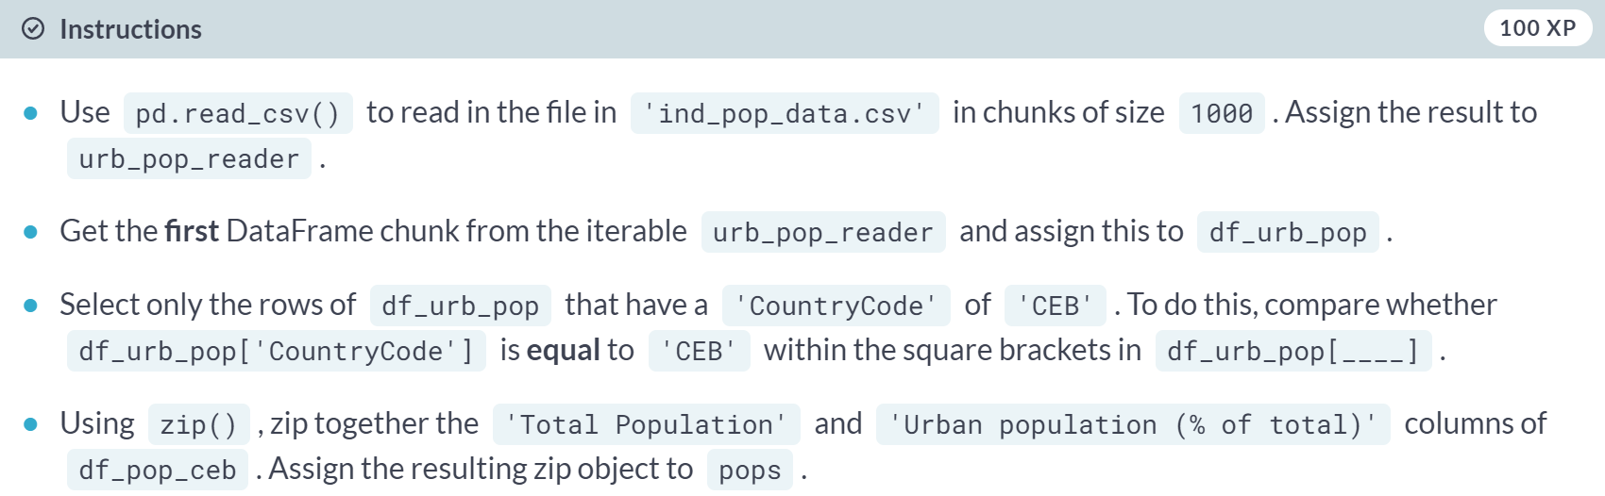  
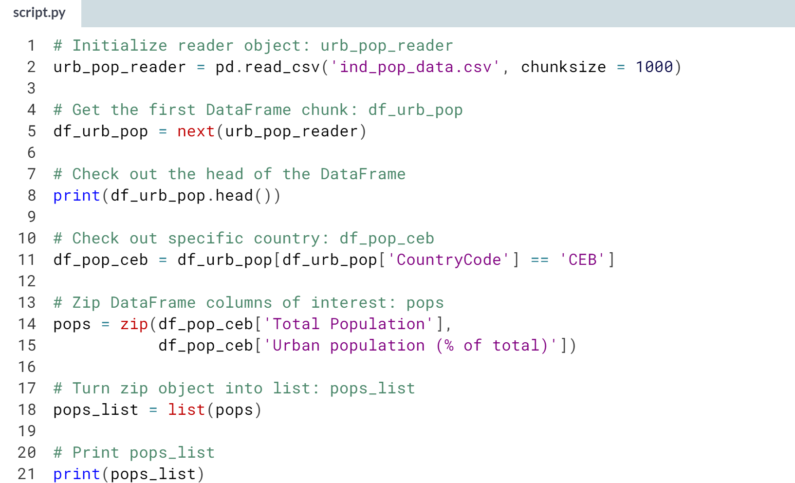  
(Result on the next page)

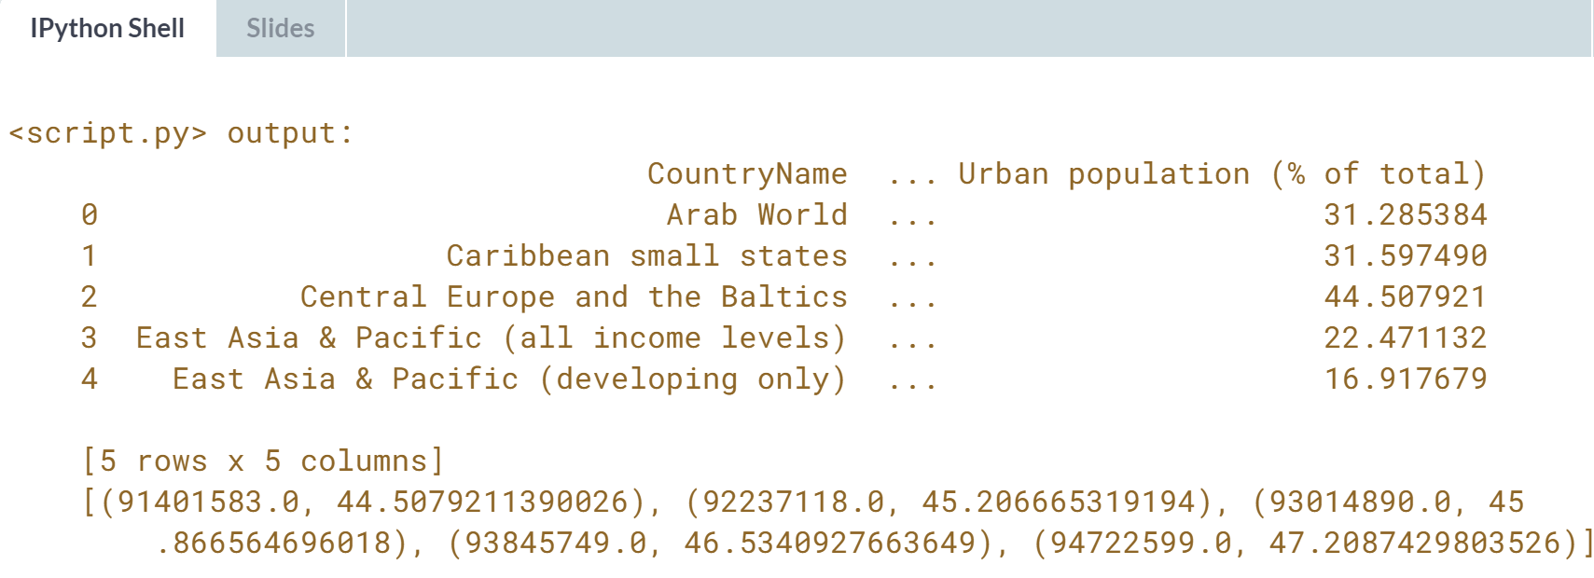  
Great work! Time to step it up a notch!

# Writing an iterator to load data in chunks (3)

You're getting used to reading and processing data in chunks by now. Let's push your skills a little further by adding a column to a DataFrame.

Starting from the code of the previous exercise, you will be using a list comprehension to create the values for a new column 'Total Urban Population' from the list of tuples that you generated earlier. Recall from the previous exercise that the first and second elements of each tuple consist of, respectively, values from the columns 'Total Population' and 'Urban population (% of total)'. The values in this new column 'Total Urban Population', therefore, are the product of the first and second element in each tuple. Furthermore, because the 2nd element is a percentage, you need to divide the entire result by 100, or alternatively, multiply it by 0.01.

You will also plot the data from this new column to create a visualization of the urban population data.

The packages pandas and matplotlib.pyplot have been imported as pd and plt respectively for your use.

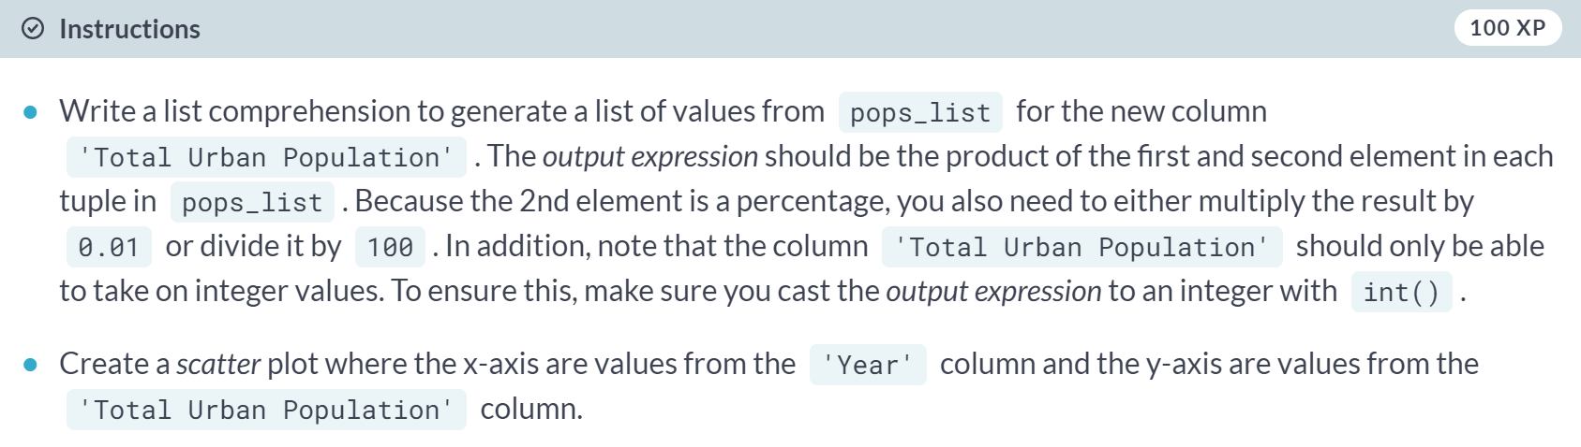  
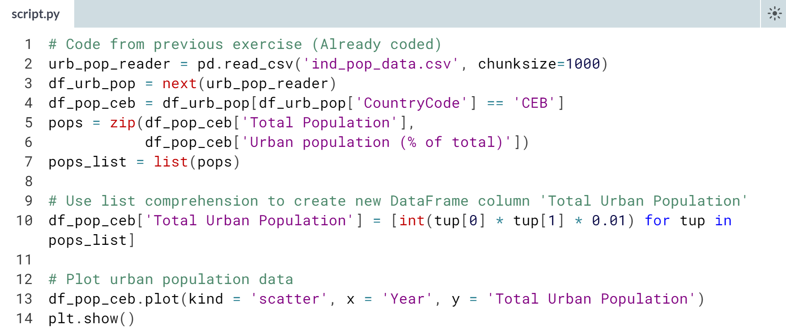

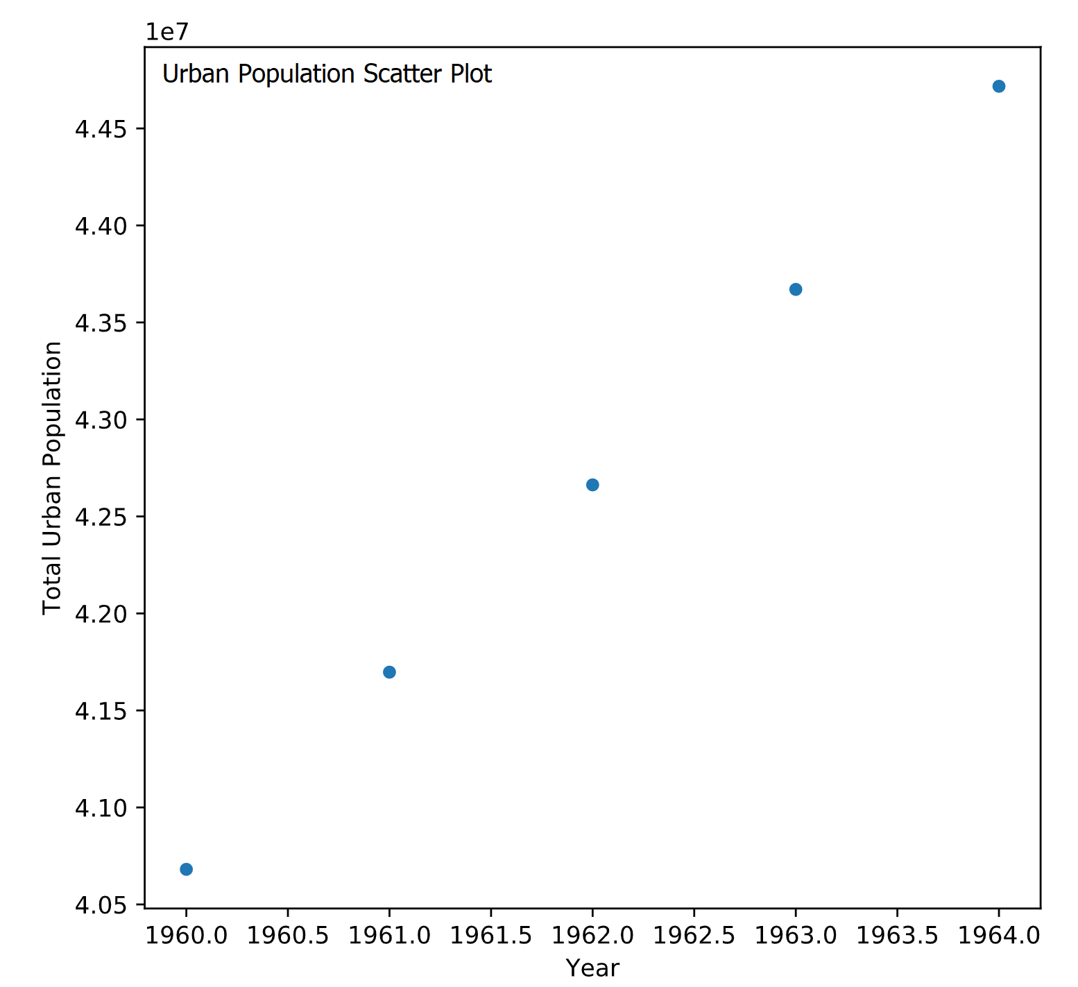

# Writing an iterator to load data in chunks (4)

In the previous exercises, you've only processed the data from the first DataFrame chunk. This time, you will aggregate the results over all the DataFrame chunks in the dataset. This basically means you will be processing the **entire** dataset now. This is neat because you're going to be able to process the entire large dataset by just working on smaller pieces of it!

You're going to use the data from 'ind_pop_data.csv', available in your current directory. The packages pandas and matplotlib.pyplot have been imported as pd and plt respectively for your use.

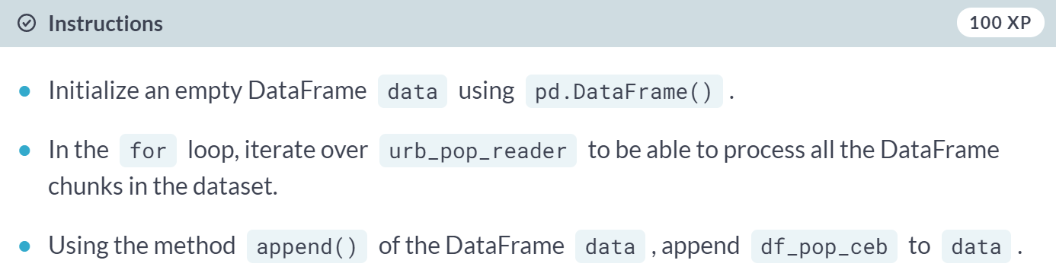

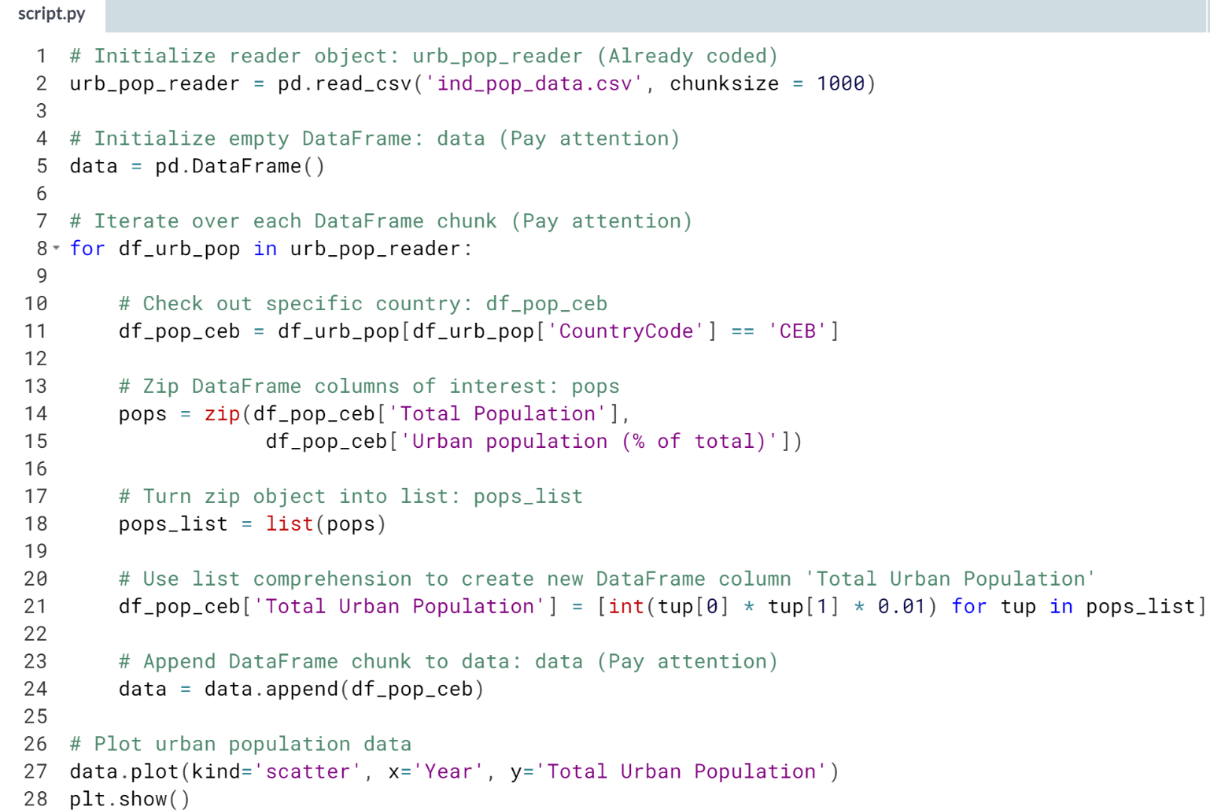

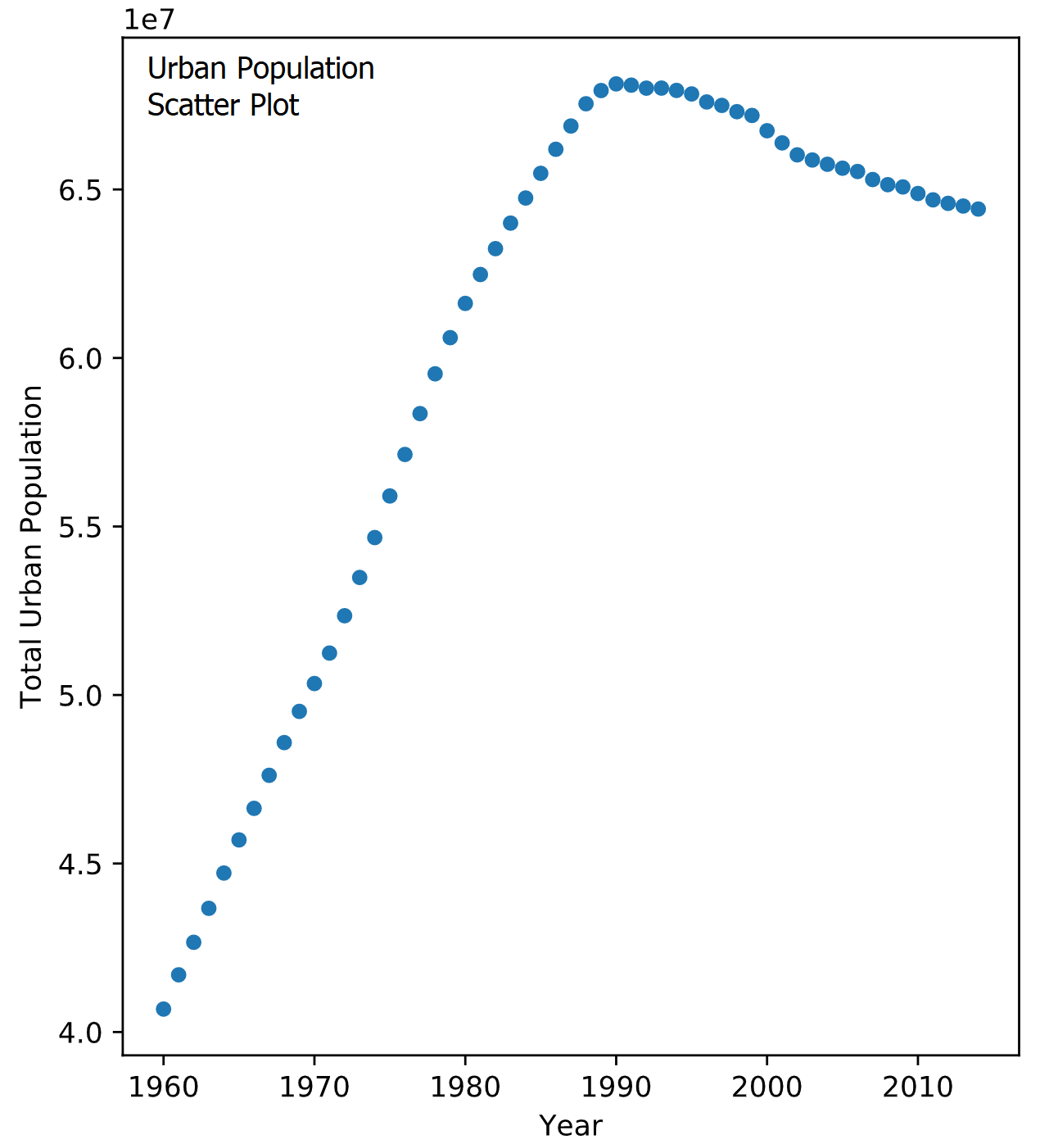

# Writing an iterator to load data in chunks (5)

This is the last leg. You've learned a lot about processing a large dataset in chunks. In this last exercise, you will put all the code for processing the data into a single function so that you can reuse the code without having to rewrite the same things all over again.

You're going to define the function plot_pop() which takes two arguments: the filename of the file to be processed, and the country code of the rows you want to process in the dataset.

Because all of the previous code you've written in the previous exercises will be housed in plot_pop(), calling the function already does the following:

* Loading of the file chunk by chunk,
* Creating the new column of urban population values, and
* Plotting the urban population data.

That's a lot of work, but the function now makes it convenient to repeat the same process for whatever file and country code you want to process and visualize!

You're going to use the data from 'ind_pop_data.csv', available in your current directory. The packages pandas and matplotlib.pyplot has been imported as pd and plt respectively for your use.

After you are done, take a moment to look at the plots and reflect on the new skills you have acquired. The journey doesn't end here! If you have enjoyed working with this data, you can continue exploring it using the pre-processed version available on [**Kaggle**](https://www.kaggle.com/worldbank/world-development-indicators).

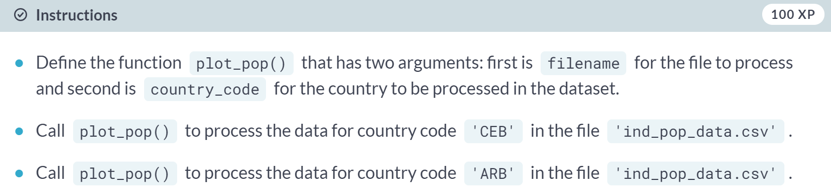

(Code on the next page)

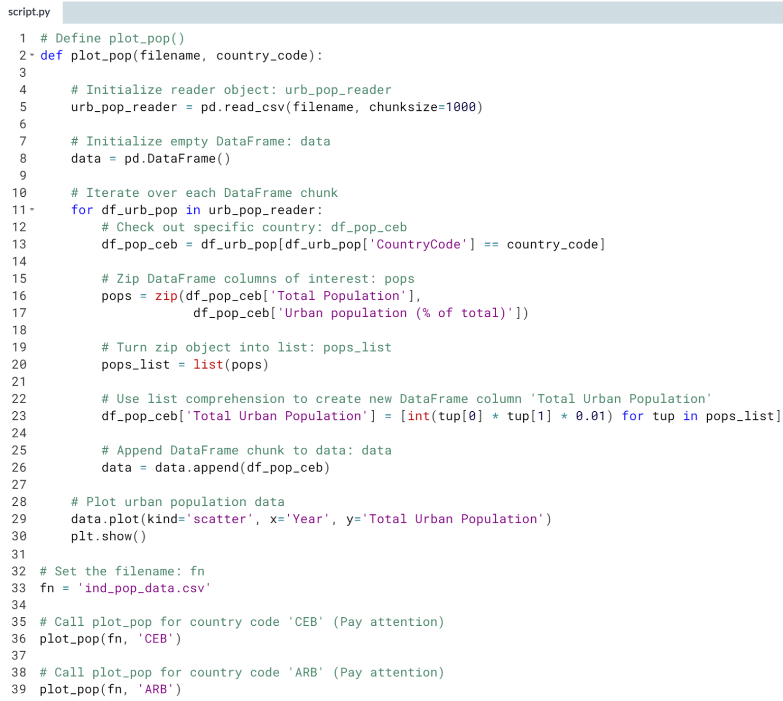  
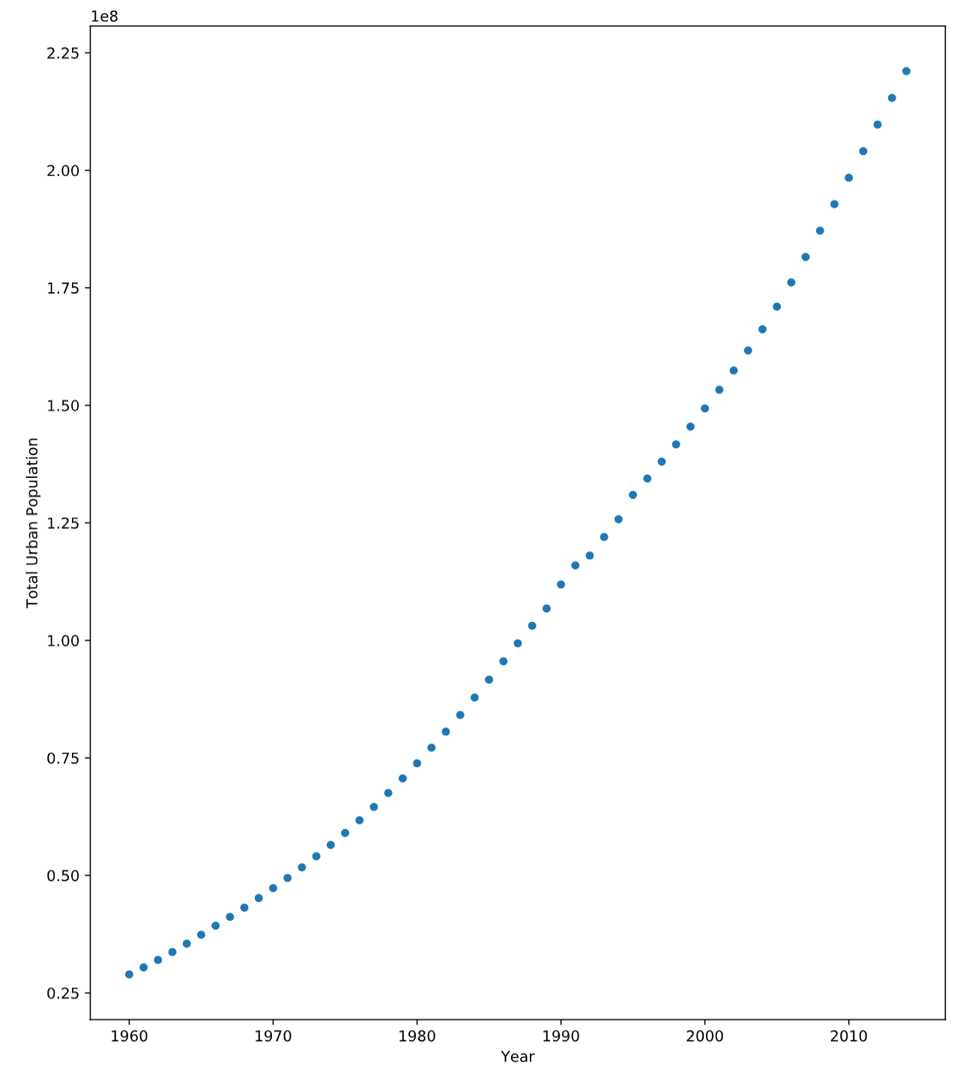



You have just used your new skills of writing user-defined functions, iterators, list comprehensions and generators to explore and extract results from the World Bank World Development Indicators dataset. These are all tools that you will utilize time and time again in your work as a Data Scientist.